Pewithall School RSHE Draft Curriculum Map

Year group | Term | Topic/theme details | Resources
EYFS  Reception | Autumn 1 | All About Me  - My family- who is in it?  - Compare and discuss with whole class.  - Families are important for children growing up because they can give love, security and stability.  - Look at community of Runcorn why is it similar or different to where Miss Jewkes lives? | • Text: And Tango makes three. Mommy, mama and me.  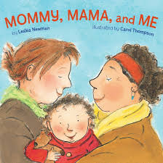  Draw a family tree
EYFS  Reception | Autumn 2 | My Choices  Making choices. To know that I can make some choices? When can I choose?  What is a good choice in my classroom?  What is a good choice?  How can I make the right choices?  To know that sometimes I do not have a choice when it is to keep me safe and well. | Class room Rules and reward systems.
EYFS  Reception | Spring 2 | My Body  To name the parts of my body and to know what they do. | Pants Resources from NSPCC  https://learning.nspcc.org.uk/media/1389/underwear-rule-teaching-resource-guidance.pdf
EYFS  Reception | Spring 2 | My Boundaries | Pants Resources from NSPCC  https://learning.nspcc.org.uk/media/1389/underwear-rule-teaching-resource-guidance.pdf  Text Train your Angry Dragon 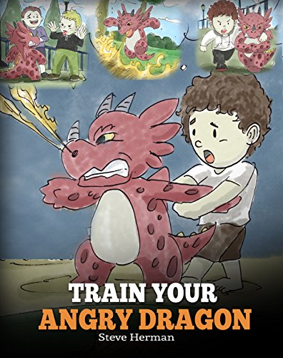
EYFS  Reception | Summer 1 | My Relationships  What is a friend?  What makes a good friend?  What do you like about friendships?  What don’t you like about friendships?  Who can you trust to help you when you have fallings out?  Develop the idea of talking to a trusted adult. | Use a story where children need to decide to trust a character or not.  Should the three little pigs let the big bad wolf in?  Who can help the pigs?
EYFS  Reception | Summer 2 | My Thoughts and Feelings  Introduce the idea of having a healthy mind.  Discuss feelings and why we may feel , happy, sad, upset, embarrassed, cross etc.  Discuss what we can do when we have these feelings. Remind the children of trusted adults. | Mirrors to look at our faces showing emotions.  Emotions cards.
Year 1 | Autumn 1 | All About Me  My school family.  To know that I am a part of my own family and the Pewithall family.  Encourage the children to think about important people in their school life and why they are important? | Photographs of school staff.
Year 1 | Autumn 2 | My Choices  How can we make year 1 a happy and safe place.  Children will know practical steps they can take to support and improve relationships.  Dojo rewards and feelings and pride.  Showing courtesy and good manners. | Dojo Reward System  Text Can a unicorn help me to make good choices?  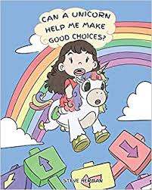  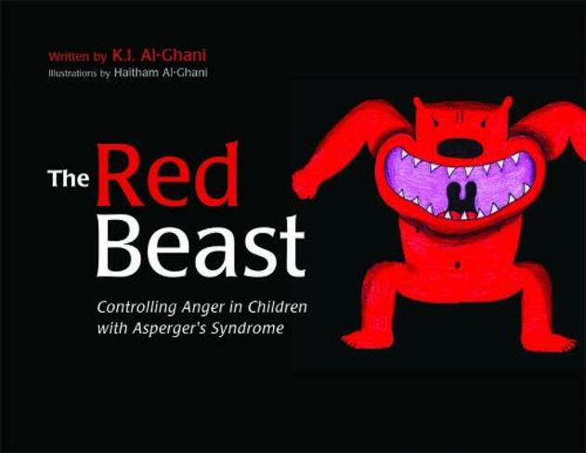  The Red Beast  K Al-Ghani
Year 1 | Spring 1 | My Body  Looking after my body. Look at the importance of exercise and healthy eating.
Year 1 | Spring 2 | My Boundaries  Who can I go to when I don’t feel ok?  Look at the issues of trust and trusted adults. | Speak out Stay Safe from the NSPCC  https://learning.nspcc.org.uk/media/2385/nspcc-speak-out-stay-safe-ks1-lesson-plan.pdf
Year 1 | Summer 1 | My Relationships  Who are my friends? Look at how they are similar to you and how they are different.  Learn how important friendships are in making us feel happy, secure and safe.  My friend is a star because … | 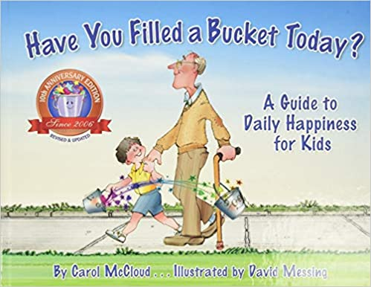Have you filled a bucket today?  How to catch a star Oliver Jeffers  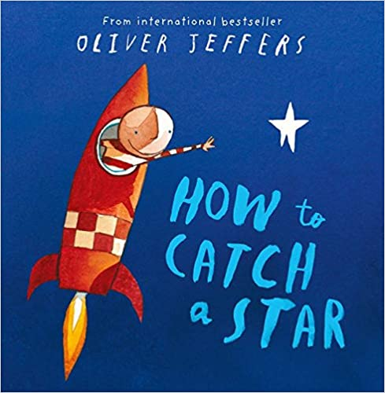
Year 1 | Summer 2 | My Thoughts and Feelings  What is a 2%er and what is a mood hoover.  Look at the Pig of happiness and positive mindsets. | Texts-The Pig of Happiness . 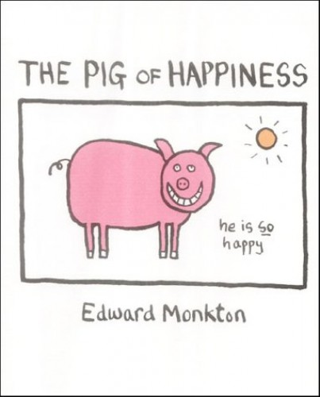  My Strong Mind  The Magic Inside you.  Have you filled a bucket today?

Ye

Year group | Term | Topic/theme details | Resources
Year 2 | Autumn 1 | All About Me  What are my interests and hobbies?  Make a mood board of the things that make you an individual | Class transition resources.
Year 2 | Autumn 2 | My Choices  To develop an understanding of empathy and to understand that the words we choose can hurt people’s feelings. | 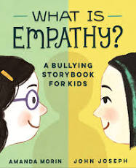Text -What is empathy?
Year 2 | Spring 1 | My Body  To know the name of my body parts. To know that boys and girls are different and bodies are different too. | Pants Resources from NSPCC  https://learning.nspcc.org.uk/media/1389/underwear-rule-teaching-resource-guidance.pdf  Text Amazing you  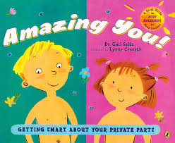
Year 2 | Spring 2 | My Boundaries  To know that some parts of my body are private.  To talk about what you like about being you (about being a boy or a girl) | Pants Resources from NSPCC  https://learning.nspcc.org.uk/media/1389/underwear-rule-teaching-resource-guidance.pdf  Speak out Stay Safe from the NSPCC  https://learning.nspcc.org.uk/media/2385/nspcc-speak-out-stay-safe-ks1-lesson-plan.pdf  Text Amazing You
Year 2 | Summer 1 | My Relationships  My friendships to know that sometimes friends have disagreements and that we can work out our fallings out.  To begin to understand how we can avoid conflict and fallings out. | Scenarios
Year 2 | Summer 2 | My Thoughts and Feelings  To know that looking after my body and my feelings is very important. To know that making healthy choices and having healthy lifestyle will make me feel good physically and mentally. | Fit for Life programme  Science resources  To make healthy snacks and drinks.
Year 3 | Autumn 1 | All About Me  To think about my future now that I am a junior. Think about my aspirations and what I would like to achieve as I grow up.  Set targets for myself and class rules. | Classroom Rules and Reward systems.
 | Autumn 2 | My Choices  To understand that the choices I make can keep me safe. Using crossings when crossing the road. Letting my parents know where I am when I am out with my friends. Wearing a helmet on my bike and scooter. Begin to understand making safe choices. Walking with friends and not alone for example. | Scenarios
 | Spring 1 | My Body  To look at my body and begin to understand what has changed and what they can do now that they could not do when they were younger. Talk about height, size, shape, teeth and how we can explore our insecurities. | School Nurse  Text-thinking Good Thoughts about Me  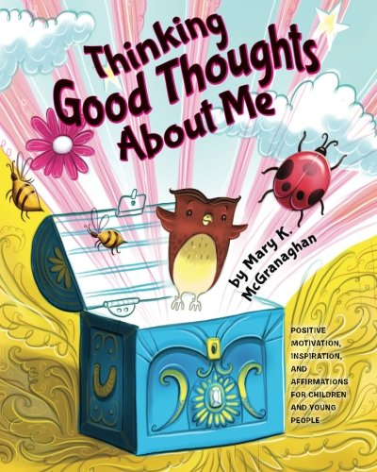  Pants Resources from NSPCC  https://learning.nspcc.org.uk/media/1389/underwear-rule-teaching-resource-guidance.pdf
 | Spring 2 | My Boundaries  To understand that I must keep myself safe online and be aware of information that I share. | Speak out Stay Safe from the NSPCC  https://learning.nspcc.org.uk/media/2385/nspcc-speak-out-stay-safe-ks1-lesson-plan.pdf  Text #Goldilocks  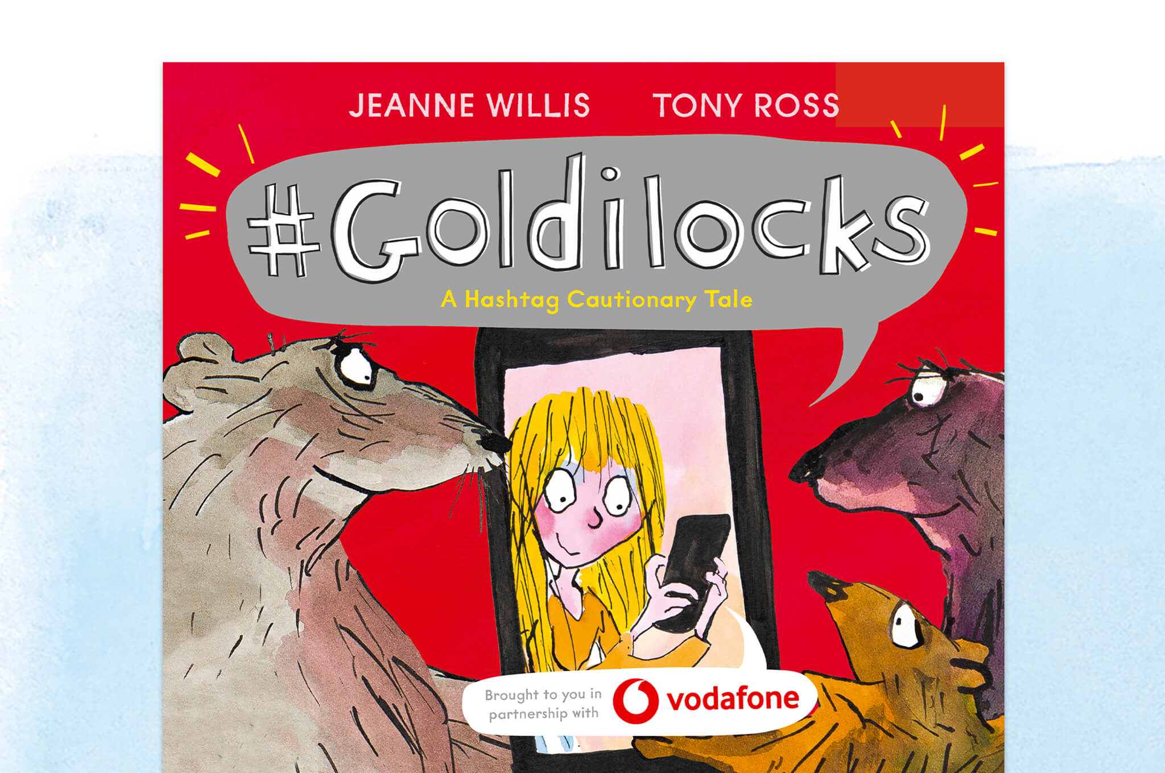
 | Summer 1 | My Relationships  Children will look at important figures who have influenced and changed the world. For example Martin Luther King (I Have a dream)and Malala Yousafzai (Education for all girls) | Assemblies  Text Malala’s Magic Pencil  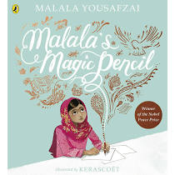
 | Summer 2 | My Thoughts and Feelings  For children to begin to evaluate their own achievements and learning and to reflect on times where they may have failed. How did that make you feel? Did it have an impact on you? Have a class debate can failure be a good thing? | Text A world without Failures  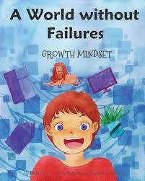  Tackling the Blues project with Everton FC
ar group

Year group | Term | Topic/theme details | Resources
Year 4 | Autumn 1 | All About Me  Children to look at their own values and qualities. When do we use those values?  Respectful, kind, helpful, a good listener, adaptable, inspiring, brave determined | Class transition resources.  Dojo ninja reward system  A Ball About me
Year 4 | Autumn 2 | My Choices  What is consent? Think about who gives consent and what we give consent for? Parents give consent for their children to keep them safe. To understand that children are able to give consent for themselves too to keep themselves safe. When you visit the doctor to the dentist you give consent for them to look at your body and to treat you.  To know that children can ask for help from a trusted adult if they feel worried, upset or if they feel they need help.  For children to identify trusted adults and for children to be aware of the NSPCC and Childline. | Speak out Stay Safe from the NSPCC  https://learning.nspcc.org.uk/media/2385/nspcc-speak-out-stay-safe-ks1-lesson-plan.pdf  Pants Resources from NSPCC  https://learning.nspcc.org.uk/media/1389/underwear-rule-teaching-resource-guidance.pdf
Year 4 | Spring 1 | My Body  What is happening to my body?  To find out about the physical changes that happen to my body as I grow up towards being a teenager. | School Nurse  Texts- What’s happening to me?  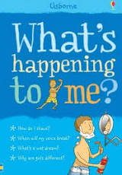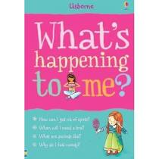
Year 4 | Spring 2 | My Boundaries  To know that I have rights to be safe but to begin to understand animal have rights just like humans.  To find out about the palm oil debate and the habitats of orangutans. | Science Habitats resources.  Text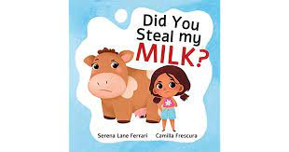
Year 4 | Summer 1 | My Relationships  Making judgements.  Have you ever thought that something would be easy and it was really hard?  Have you ever seen a lovely cake and when you tasted it wasn’t very nice? To talk about how we can wrongly make assumptions or make a judgement about something or some one.  For the children to explore the process that we can sometimes wrongly judge somebody before knowing them. | Scenario cards.
Year 4 | Summer 2 | My Thoughts and Feelings  To begin to understand respect. Reflect back to learning on human and animal rights. To understand the importance of respecting others even when we may be different or think differently. We all have different views, personalities, beliefs and are from different backgrounds. | Fit for Life programme  Science resources  To make healthy snacks and drinks.
Year 5 | Autumn 1 | All About Me  Children to design their own social media profile. Review it. Doe my social media profile keep me safe?  Children must be aware of the concept of privacy and sharing appropriate information on line. | Classroom Rules and Reward systems.  Share Aware NSPCC  ThinkUknow-  Rules for social media
Year 5 | Autumn 2 | My Choices  Giving consent and resolving conflicts.  Look at different scenarios in circle time and class discussions. How would you solve this falling out? What advice would you give?  Is it ok to post a picture of your friend online? | Text #Goldilocks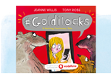
Year 5 | Spring 1 | My Body  How is my body changing?  How can I look after my changing body? Keeping myself clean, washing my face, deodrants etc.  Look at the reproductive system through the science curriculum. Focusing on lifecycles. | Text-Hair in Funny Places 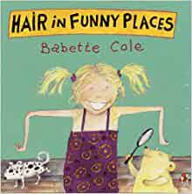  Growing up Great!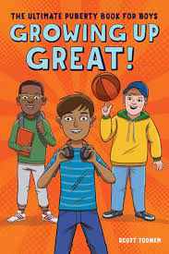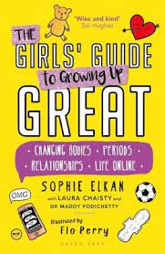  Ruby Luna’s Curious Journey A Girls anatomy book  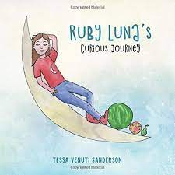  School Nurse  NHS-5 ways to well being online resources.  BBC Iplayer operation ouch Puberty special
Year 5 | Spring 2 | My Boundaries  Online Relationships.  To understand that respect must be present when using social media and using social media apps.  How can I show respect and awareness when using social media.  Words can hurt and have a consequence. Refer to Jesy Nelson Documentary (short clip) | Speak out Stay Safe from the NSPCC  https://learning.nspcc.org.uk/media/2385/nspcc-speak-out-stay-safe-ks1-lesson-plan.pdf  Share aware NSPCC  PSCO-Online safety
Year 5 | Summer 1 | My Relationships  To understand that there are different types of friendships. Friendships in school, at home, friendship with boys and girls. To understand that romantic relationships can be with somebody of the same sex and to explore the word gay. | Text King and King  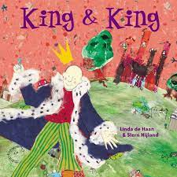  Text-The Princes and the treasure  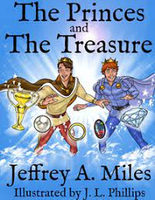
Year 5 | Summer 2 | My Thoughts and Feelings  Children to discuss the idea of marriage.  That marriage represents a formal and legally recognised commitment of two people to each other which is intended to be lifelong.  From 2013 same sex couples were able to legally marry. How do you think same sex couples felt before this? | Photo cards  Newspaper reports

Year group | Term | Topic/theme details | Resources
Year 6 | Autumn 1 | All About Me  Alien Nation  How would you create a world so that everybody feels respected and supported. | Class transition resources.  Text Alien Nation  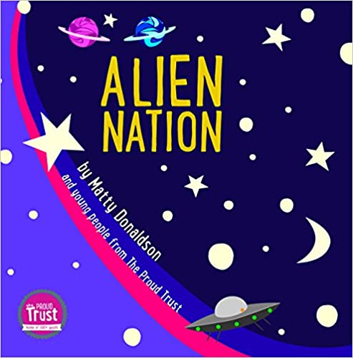
Year 6 | Autumn 2 | My Choices  How are you going to choose friends in your new school?  For children to know how to form and maintain positive relationships. How do you resolve conflicts? How to seek help when support and help is needed. | Speak out Stay Safe from the NSPCC  https://learning.nspcc.org.uk/media/2385/nspcc-speak-out-stay-safe-ks1-lesson-plan.pdf  NSPCC Making Sense of Relationships resources.  Lesson 1 Secondary School.
Year 6 | Spring 1 | My Body  What are periods? What Changes for boys?  Reproduction revisited as part of the science curriculum. | School Nurse  Texts- What’s happening to me?  -Hair in Funny Places  Growing up Great!  Ruby Luna’s Curious Journey A Girls anatomy book  Newsround Special All About Periods CBBC IPlayer
Year 6 | Spring 2 | My Boundaries  Online Relationships  For children to consider their relationships online. To critically consider their online friendships and have an awareness of the risks associated with relationships with people they have never met. | Speak out Stay Safe from the NSPCC  https://learning.nspcc.org.uk/media/2385/nspcc-speak-out-stay-safe-ks1-lesson-plan.pdf  NSPCC Making Sense of Relationships resources.  Lesson 3 Healthy Online Relationships.
Year 6 | Summer 1 | My Relationships  Who is important in my life? Why are they important?  How do I maintain these relationships | NSPCC Making Sense of Relationships resources.  Lesson 2 Changing Friendships
Year 6 | Summer 2 | My Thoughts and Feelings  Children to reflect on the importance of self respect and how this can link to our happiness.  Think about self talk and the messages that we give to ourselves. How we must be kind to ourselves, have courage and believe in ourselves to meet the challenges of a new school. | Transition resources from secondary schools.  NSPCC Making Sense of Relationships resources.  Lesson 1 secondary school  Tackling the Blues with Everton FC

