**School**

**Pewithall Primary School**

**Parent**

**Parent/Carer……………………………………………………………………**

**Child**

**Child’s name……………………………..…………. Class…………**

**The school will do its best to:**

* Provide an environment which has been risk assessed in response to the COVID-19 infection;
* Adhere to the social distancing rules as set out by the government as much as we reasonably can;
* Provide a curriculum that meets the needs of your child’s well-being, mental health and academic needs;
* Contact parents/carers if your child displays symptoms of COVID-19;
* Inform you if staff or children in your child’s ‘bubble’ test positive for COVID-19 as this will mean your child will need to self-isolate for at least 14 days;
* Continue our clear and consistent approach to rewards and sanctions for children as set out in the Behaviour Policy and Policy Addendum as well the expectations outlined in this agreement.
* Communicate between home and school through notices, newsletters, text, email and the school website.

**To help my child at school, I know and understand that:**

* If my child, or anyone in my household, shows symptoms of COVID-19, I will not send them to school, we will self-isolate for 14 days as a family, I will get them tested and I will let the school know as soon as possible via telephone.
* If my child shows symptoms of COVID-19 at school, I will collect my child from school immediately.
* On my commute, and when dropping my child off and picking them up, I will adhere to the 2 metre social distancing rules.
* When dropping off and picking up, I will strictly stick to the school timings for my child.
* My child may bring a packed lunch and water bottle to school. They may take reading books and homework to and from school.
* My child will have their temperature taken if they feel or present as being unwell
* I will need to remind my child about social distancing rules but accept they are difficult to follow and that my child may not always do this successfully
* My child will need to use good respiratory and hand hygiene.
* Only essential visits to the school office will be allowed. Please observe the ‘one in one out’ rule and adhere to social distancing.
* I need to support all staff in their efforts to create an ‘as safe as possible’ environment during this time.
* Read all letters/messages/emails that are sent home.
* I need to inform the school immediately of any changes to parents/carer and emergency contacts details.

**I will do my best to:**

* Adhere to the social distancing rules in class and in the playground.
* Tell an adult if I feel unwell.
* Not bring things into school from home or take things home from school. Except for packed lunches, water bottles, reading books and homework.
* Only use the equipment provided to me by school and no other.
* Only mix with children in my bubble.
* Only enter and exit the school building from the designated gate and follow the one-way system at all times.
* Follow good respiratory hygiene: coughing and sneezing into elbow or tissue (catch it-bin it-kill it).
* Follow good hand hygiene – use soap and water for 20 seconds/ hand sanitiser.
* Only use public transport if absolutely necessary and ensure I socially distance and wear a face covering, if I do.

* Behave well at all times to maintain the safety of myself and others.

Signed: **Mr D Baugh** Date:02.09.2020

Signed by parent/carer…………………………….………………..………….. Date……………………………….

Signed by child………………………….………………………………..…..…… Date……………………………….

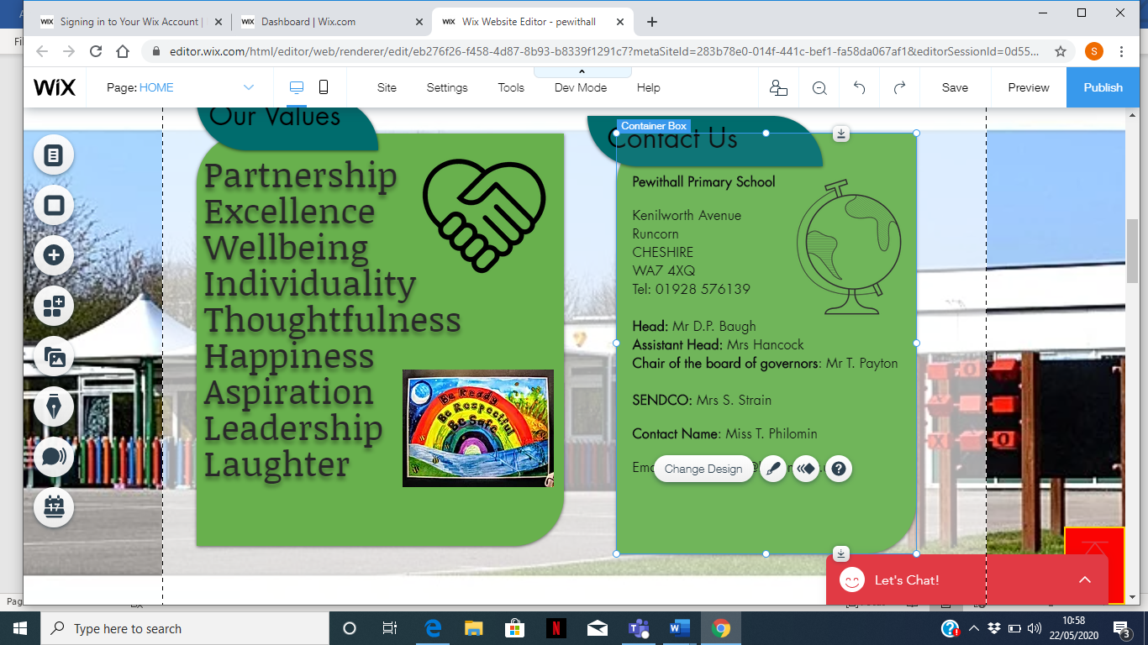

**Partnership**

**Excellence**

**Wellbeing**

**Individuality**

**Thoughtfulness**

**Happiness**

**Aspiration**

**Leadership**

**Laughter**

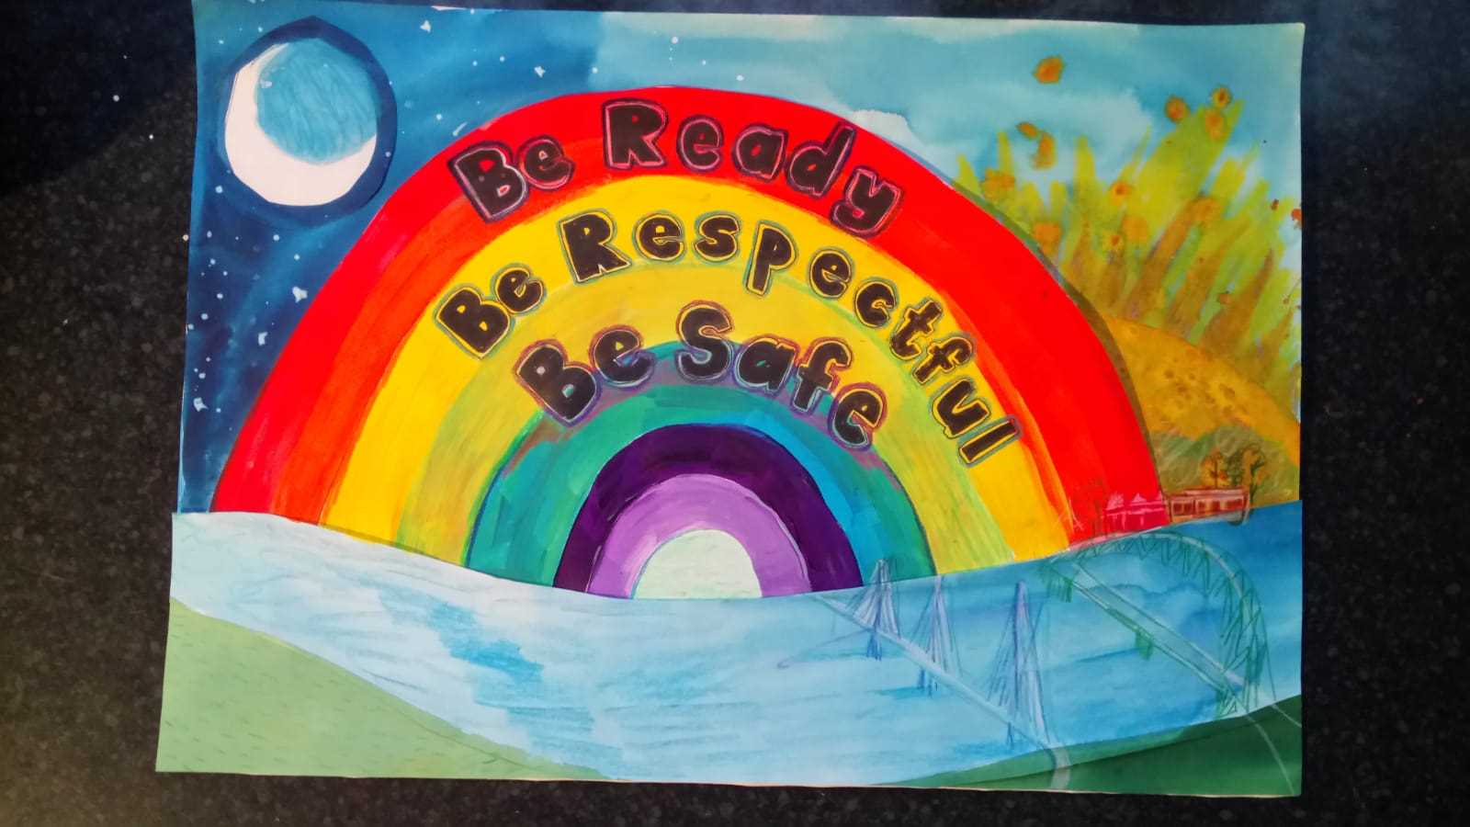

**COVID-19**

**Home School Agreement**

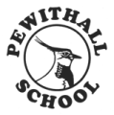

**Pewithall Primary School**

**Kenilworth Ave**

**Runcorn**

**Cheshire WA7 4XQ**

**01928 576139**

**admin.pewithall@halton.gov.uk**



