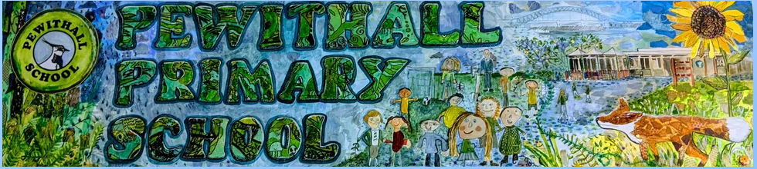

CURRICULUM INFORMATION 2023-2024

YEAR 4

Teachers: Mrs O’Neill (Monday, Tuesday, Thursday Friday)
Mrs Strain (Wednesday)

Teaching Assistant: Mrs Payton (each day)

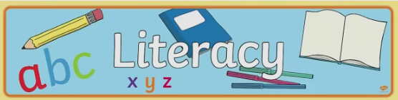
This year your child will study:
Reading:
Reading is integral to learning across the curriculum. In addition to this, Guided Reading sessions are taught once a week in small groups. We use these sessions to develop comprehension skills through high quality discussions and from reading a range of stories, poems, and non-fiction.

Writing
For writing this year we will continue to use the Literacy Company's Pathways to Write Scheme.


Pathways to Write is a proven methodology built around units of work which develops spelling, grammar, punctuation vocabulary, reading and writing skills through the mastery approach. The units are linked to high quality texts which means lessons are engaging and purposeful.
Here are some of the books that will inspire you in Year 4.....
Autumn 1 | Autumn 2 | Spring 1 | Spring 2 | Summer 1 | Summer 2
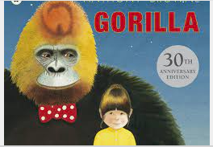 | 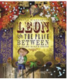 | 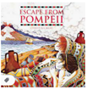 | 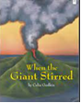 | 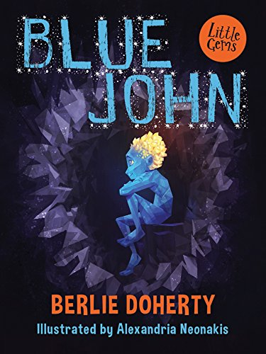 | 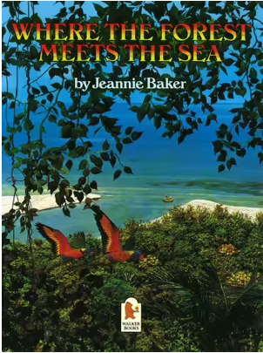

Spelling, Punctuation & Grammar
In Year 4 the children will learn how to use:
•Fronted adverbials
•Paragraphs
•Appropriate choice of pronoun or noun across sentences to avoid repetition
•Inverted commas and other punctuation to mark direct speech
•Apostrophes to mark singular and plural possession

In year 4 we use Sum Dog to support learning spellings. Spellings are from the Year 3 and 4 statutory lists and are a mixture of words pupils frequently use in their writing and those that they often misspell. We will also explore the origins of some spellings.

Spoken Language
Children will be given opportunities to develop their confidence and competence in spoken language and listening skills.

Handwriting
To achieve Expected Standard in Literacy at the end of Key Stage 2 children must have developed a fluent, legible handwriting style. We teach the children Letter Join so that they have the best chance of achieving their potential in Literacy.



What can you do to help?
- Encourage your child to read, read, read!
- Ask questions about their reading – what do you think will happen next? – Why do you think that happened? – Who is your favourite character? – Why?
- Help your child to learn their weekly spellings, use the Look-Cover-Say-Write- check method and Log on to Sum Dog challenges.
- Encourage your child to practice handwriting by giving them reasons for writing.

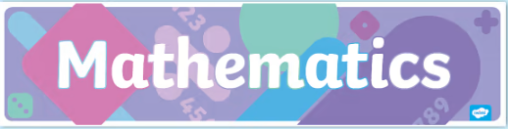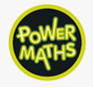
In Year 4, we use Power Maths as a basis of our maths lesson. This is an exciting class mastery approach, which has been recommended by the DfE, that works for every child. It is based upon the concrete, pictorial, and abstract approach.

Every lesson is divided into sections that involve plenty of discovery, sharing, collaboration, practice, and reflection. Children are encouraged to solve problems each day using concrete resources, pictorial representations, and abstract thinking.

At the heart of this programme is the idea that all children can achieve and be successful mathematicians with the right growth mindset.

During the year your child will learn:-
Term 1
Number and Place Value
- Recognise the place value of each digit in a four-digit number (thousands, hundreds, tens, and ones
- Round any number to the nearest 10, 100 or 1,000
- Count in multiples of 6, 7, 9, 25 and 1,000
- Identify, represent and estimate numbers using different representations
- Recognise the place value of each digit in a four-digit number (thousands, hundreds, tens, and ones)
- Order and compare numbers beyond 1,000
- Read roman numerals to 100 (i to c) and know that over time, the numeral system changed to include the concept of zero and place value
- Find 1,000 more or less than a given number
- Round any number to the nearest 10, 100 or 1,000
- Solve number and practical problems that involve all of the above and with increasingly large positive numbers
- Count in multiples of 6, 7, 9, 25 and 1,000
- Count backwards through zero to include negative numbers
Number – addition and subtraction
- Add and subtract numbers with up to 4 digits using the formal written methods of columnar addition and subtraction where appropriate
- Estimate and use inverse operations to check answers to a calculation
- Solve addition and subtraction two-step problems in contexts, deciding which operations and methods to use and why
Measurement
- Convert between different units of measure [for example, kilometre to metre, hour to minute
- Measure and calculate the perimeter of a rectilinear figure (including squares) in centimetres and metres
Number – multiplication and division
- Recall multiplication and division facts for multiplication tables up to 12 × 12
- Use place value, known and derived facts to multiply and divide mentally, including: multiplying by 0 and 1; dividing by 1; multiplying together three numbers

Term 2
Number – multiplication and division
- Solve problems involving multiplying and adding, including using the distributive law to multiply two-digit numbers by one digit, integer scaling problems and harder correspondence problems such as n objects are connected to m objects
- Multiply two-digit and three-digit numbers by a one-digit number using formal written layout
- Recognise and use factor pairs and commutativity in mental calculations
- Multiply two-digit and three-digit numbers by a one-digit number using formal written layout
- Use place value, known and derived facts to multiply and divide mentally, including: multiplying by 0 and 1; dividing by 1; multiplying together three numbers
Measurement
- Find the area of rectilinear shapes by counting squares
- Estimate, compare and calculate different measures, including money in pounds and pence
Number – fractions (including decimals)
- Count up and down in hundredths; recognise that hundredths arise when dividing an object by one hundred and dividing tenths by ten
- Recognise and show, using diagrams, families of common equivalent fractions
- Solve problems involving increasingly harder fractions to calculate quantities, and fractions to divide quantities, including non-unit fractions where the answer is a whole number
- Add and subtract fractions with the same denominator
- Recognise and write decimal equivalents of any number of tenths or hundredths
- Find the effect of dividing a one- or two-digit number by 10 and 100, identifying the value of the digits in the answer as ones, tenths and hundredths

Term 3
Number – fractions (including decimals)
- Recognise and write decimal equivalents of any number of tenths or hundredths
- Find the effect of dividing a one- or twodigit number by 10 and 100, identifying the value of the digits in the answer as ones, tenths, and hundredths
- Compare numbers with the same number of decimal places up to two decimal places
- Round decimals with one decimal place to the nearest whole number
- Recognise and write decimal equivalents to ¼, ½, ¾
- Solve simple measure and money problems involving fractions and decimals to two decimal places
Measurement
- Estimate, compare and calculate different measures, including money in pounds and pence
- Convert between different units of measure, for example, kilometre to metre, hour to minute.
Statistics
- Interpret and present discrete and continuous data using appropriate graphical methods, including bar charts and time graphs
- Solve comparison, sum and difference problems using information presented in bar charts, pictograms, tables, and other graphs
Geometry – properties of shapes
- Identify acute and obtuse angles and compare and order angles up to two right angles by size
- Compare and classify geometric shapes, including quadrilaterals and triangles, based on their properties and sizes
- Identify lines of symmetry in 2D shapes presented in different orientations
- Complete a simple symmetric figure with respect to a specific line of symmetry
Geometry – position and direction
- Describe positions on a 2D grid as coordinates in the first quadrant
- Plot specified points and draw sides to complete a given polygon
- Describe movements between positions as translations of a given unit to the left/right and up/down

What can you do to help?
- Encourage your child to learn all times tables including division facts (TT Rockstars).
- Support your child with weekly maths homework
- Encourage your child to access Sumdog so that they can access lots of maths games.

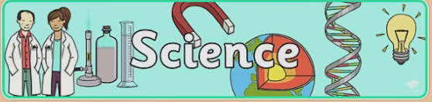
Science is taught using a scheme called Developing Experts. In lessons children will be exposed to scientific vocabulary, watch videos of real-life scenarios where the science concept they are learning about is being used. They will engage in experiments and will have opportunities to work scientifically.

Electricity
- Identify common appliances that run on electricity
- Construct a simple series electrical circuit, identifying and naming its basic parts, including cells, wires, bulbs, switches and buzzers
- Identify whether a lamp will light in a simple series circuit, based on whether the lamp is part of a complete loop with a battery
- Recognise that a switch opens and closes a circuit and associate this with whether a lamp lights in a simple series circuit
- Recognise some common conductors and insulators, and associate metals with being good conductors.

Sound
- Identify how sounds are made, associating some of them with something vibrating
- Recognise that vibrations from a sound travel through a medium to the ear.
- Find patterns between the pitch of a sound and features of the object that produced it
- Find patterns between the volume of a sound and the strength of the vibrations that produced it.
- Recognise that sounds get fainter as the distance from the sound source increases.

States of Matter
- Compare and group materials together, according to whether they are solids, liquids or gases
- Observe that some materials change state when they are heated or cooled, and measure or research the temperature at which this happens in degrees Celsius (°C)
- Identify the part played by evaporation and condensation in the water cycle and associate the rate of evaporation with temperature.

Living things and their habitats
- Recognise that living things can be grouped in a variety of ways
- Explore and use classification keys to help group, identify and name a variety of living things in their local and wider environment
- Recognise that environments can change and that this can sometimes pose dangers to living things
Food and Digestion
- Describe the simple functions of the basic parts of the digestive system in humans
- Identify and describe functions of teeth
- Construct and interpret a variety of food chains, identifying producers, predators and prey.

What can you do to help?
- Visit the library to find out more about the science topic being covered or look for information on the Internet
- Talk about science in our every day lives, relating it to the topics taught.
- Access online learning using the pupil login for Developing Experts.


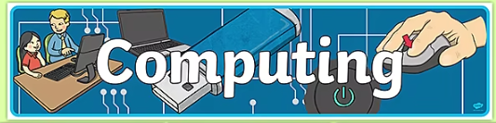
Children will have weekly computing lessons in the suite. Throughout the year children will be taught:

Information Technology
Graphic Design
- Create an icon using different shapes and fill tools.
- Combine shapes and lines, then arrange them in front/behind each other.
- Combine shapes, colour and text to re-create an icon.
- Change the colour, size and style of text to match an icon, then arrange images and use masking and opacity tools.
Animation
- Create a stop-motion video by duplicating slides that include backgrounds and shapes.
- Create animation using transition and animation effects (morph, motion paths, pulse etc), including taking and editing a screenshot.
- Animate individual elements of objects.
- Create animated GIF files by animating pixels.
Data Handling
- Change appearance of cells in a spreadsheet (fill colour and border) then add and align text.
- Find and add data to a spreadsheet, resize cells and use the software to create a suitable chart with a title.
3D Design
- Change appearance of cells in a spreadsheet (fill colour and border) then add and align text.
- Find and add data to a spreadsheet, resize cells and use the software to create a suitable chart with a title.
Video Editing
- Add scene images.
- Add scripted voiceover audio, adjust the volume and crop clips (including splitting a clip).
- Add more clips and use transition effects.
Add titles.
- Use elements such as shapes.
- Add music background music and adjust the volume.
- Export a project.

E-Book Creation
- Choose a suitable page shape and add a title and subtitle.
- Change the background colour/texture of a page.
- Add, resize and change the colour of a shape then copy and paste it.
- Search for and add suitable images then resize and position them.
- Create another page with a background, image, shapes and text.
- Add an audio recording of the page text, including hiding it behind an object.
- Use hyperlinks for navigation between the pages.
Digital Literacy
Internet Research
- Use search technologies to find specific pieces of information.
- Understand features of an Internet Browser.
- Reference the correct source of information.
- Be discerning in evaluating digital content.
- Check the internet for fake news by cross-referencing facts.
Inside a Computer
- Understand what important parts of inside a computer or mobile device do to help with the performance (CPU, Fan, Hard Drive, RAM, Graphics Card).
- Understand that memory is measured in bytes and gigabytes.
- Use search filters on websites to find suitable information.
E-Safety
- Understand what to do if something upsets you online.
- Understand why and how people can be nasty online.
- Describe the term ‘sharing online’ and why we need to get permission to share photos and videos of other people.
- Understand why people pretend to be someone else online.
- Understand why we only talk to people we know in the real world, when online.
- Understand why we should not always trust what we read online and how to check
- Understand the importance of being kind in the real world and also online.
- Understand the importance of using avatars and how to make them.

Computer Science
Programming in Scratch
- Program inputs with loops, selection and sensing for interactions.
- Work with variables and various forms of input and output.
- Debug programs that accomplish goals. (correcting errors)
- Use selection, data variables and operators.
- Program a virtual robot using Scratch blocks.

What can you do to help?

- If your child has access to a computer at home, please encourage them to use it gaining experience of what we have learnt in school by logging in to ilearn2.
- Talk with your child about E-Safety.
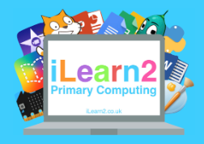

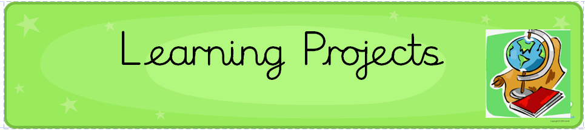
There are four Learning Projects in Y4.

- The Romans -What did the Romans to for Britain?
- Volcanoes- How do Volcanoes affect the lives of the people around them?
- Ancient Greece- How Can We Find Out About the Civilisation of Ancient Greece?

These projects concentrate on building knowledge and skills in History (Discover), Geography (Explore), Art, Design & Technology, Music and Drama (Create).

History
Chronological Understanding
As historians Year 4 pupils can:
- Use dates and historical terms to describe events with confidence.
- Use a timeline within a specific time in history to set out the order things may have happened.
- Recognise and quantify the different time periods that exist between different groups that invaded Britain.
- Confidently place events, artefacts and historical figures on a timeline using dates.
- Understand the concept of change over time, representing this, along with evidence, on a timeline?
- Understand and use appropriate historical vocabulary to communicate, including: dates, time period, era, change, chronology, ancient, century, decade.
- Understand and use the key words from the Knowledge Organisers from Y4.

Historical Enquiry
- Use written accounts and physical evidence to ask their questions and find answers to questions about the past.
- Suggest suitable sources of evidence for historical enquiry.
- Use more than one source of evidence for historical enquiry in order to gain a more accurate understanding of history.
- Recognise the part that archaeologists have had in helping us understand more about what happened in the past and why it had happened.
- Use research skills in finding out facts about the time period being studied.
- Through my research, compare and contrast different forms of evidence.
- Research what it was like for men, women and children in a given period from the past and use different forms to present findings.
Knowledge and Understanding
As historians Year 4 pupils can:
- Suggest why certain events happened as they did in history.
- Suggest why certain people acted as they did in history.
- Explain how events from the past have helped shape our lives today.
- Appreciate why Britain would have been an important country to have invaded and conquered.
- Describe changes that have happened in the locality of the school throughout history.
- Give a broad overview of life in Britain during Roman times.
- Compare some of the times studied with those of other areas of interest around the world.
- Describe the social, ethnic, cultural, or religious diversity of past societies.
- Describe the characteristic features of the past, including ideas, beliefs, attitudes and experiences of men, women, and children.
- Research different accounts of an historical event, explaining some of the reasons why the accounts may differ.
- Suggest causes and consequences of some of the main events and changes in history.
- Use literacy, numeracy and computing skills to a good standard to communicate information about the past.

Geography
Locational Knowledge
As geographers Year 4 pupils can:
- Describe where the United Kingdom and countries in Europe are located, and name and locate some of their cities.
- Locate where they live in the UK using locational terminology (north, south, east, west) and the names of nearby counties.
- Locate and describe some human and physical characteristics of the UK. (E.g., Use a copy of a map of the British Isles and locate and label the main British rivers. Add the names of settlements at the mouth of the rivers.)

Place Knowledge
As geographers Year 4 pupils can:
- Identify geographical similarities and differences through the study of human and physical geography of a region in a European country (Italy).

Physical Geography
As geographers Year 4 pupils can:
- Describe and understand key physical aspects of Europe including:
- Climate zones, biomes, vegetation belts, mountains, volcanoes, rivers
- Distribution of natural resources including energy, food, minerals and water.
Human Geography
As geographers Year 4 pupils can:
- Describe and understand key human aspects of a European country (Italy):
- including:
- Economic activity including trade links, types of settlement and land use, and the distribution of natural resources including energy, food, minerals, and water.

Geographical Skills
As geographers Year 4 pupils can:
- Use physical maps to describe key physical and human characteristics of regions in Europe.
- Use globes and atlases to locate places studied in relation to the Equator, latitude and longitude and time zones.
- use four-figure grid references.
- give direction instructions up to eight compass points.
- adeptly use large-scale maps outside.

Field work
As geographers Year 4 pupils can:
- In a group, carry out fieldwork in the local area selecting appropriate techniques
- Make a map of a short route with features in the correct order and in the correct places.
- Make a simple scale plan of a room.
- Present information gathered in fieldwork using simple graphs.
- Use the zoom function of a digital map to locate places.

Art
Drawing
As artists Year 4 pupils can:
- Understand that artists and illustrators interpret narrative texts and create sequenced drawings.
- Understand artists can work with pattern for different reasons: Understand Surface Pattern Designers work to briefs to create patterns for products: Artists’ work with pattern to create paintings or other works.
- Understand working with pattern uses lots of different concepts including repetition, sequencing, symmetry.

- Understand that patterns can be purely decorative or hold symbolic significance. They can be personal or cultural.
- Interpret poetry or prose and create sequenced images in either an accordion or comic format. Work in a variety of media according to intention, including handwriting pen, graphite or ink.
- Use colour, composition, elements, line, shape to create pattern working with tessellations, repeat pattern or folding patterns.
- Use a variety of drawing media including charcoal, graphite, wax resist and watercolour to make observational and experimental drawings. To feel able to take creative risks in pursuit of creating drawings with energy and feeling.

Making
As artists Year 4 can:
- Understand that a plinth is a device for establishing the importance or context of a sculptural object.
- Understand that artists can re-present objects, in a particular context with a particular intention, to change the meaning of that object.
- To understand that sometimes people themselves can be the object, as in performance art.
- To understand that make sculpture can be challenging. To understand it takes a combination of skills, but that we can learn through practice. That it is ok to take creative risks and ok if things go wrong as well as right.

Painting
As artists Year 4 pupils can:
- Understand that still life name given to the genre of painting (or making) a collection of objects/elements.
- That still life is a genre which artists have enjoyed for hundreds of years, and which contemporary artists still explore today.

Purpose/Visual Literacy/Articulation
As artists Year 4 can:
- Look at the work of illustrators and graphic artists, painters and sculptors. Understand the processes, intentions an outcome of different artists, using visual notes in a sketchbook to help consolidate and own the learning.
- Understand artists often collaborate on projects, bringing different skills together.
- Deconstruct and discuss an original artwork, using the sketchbooks to make visual notes to nurture pupils own creative response to the work.
- Understand we may all have different responses in terms of our thoughts and the things we make. That we may share similarities. Understand all responses are valid.

Music
We use Charanga to deliver weekly music lessons.

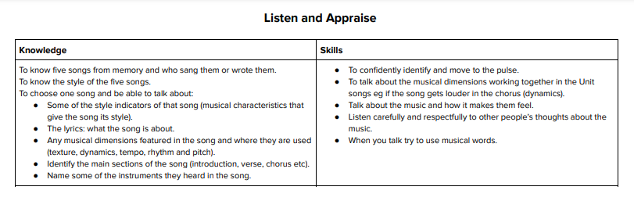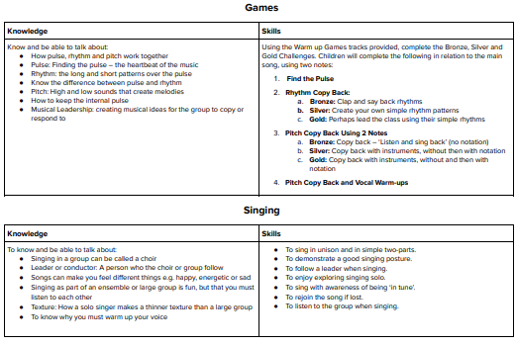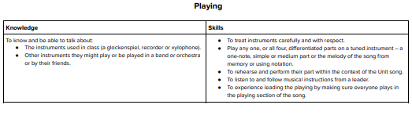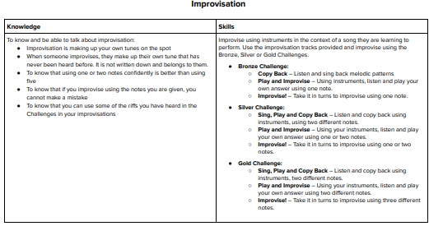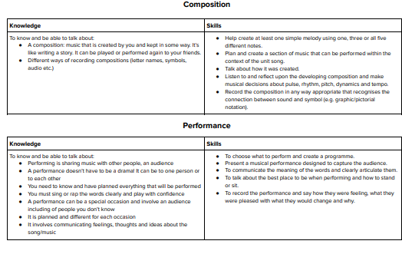



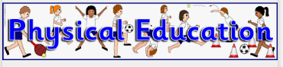

Physical Education is delivered weekly by Multiflex. Throughout Year 4 children will build on their prior skills in the following areas: -

Gymnastics

- To identify and practise body shapes.
- To identify and practise symmetrical and asymmetrical body shapes.
- To construct sequences using balancing and linking movements.
- To use counterbalances and incorporate them into a sequence of movements.
- To perform and evaluate own and others’ sequences.

Dance

- To identify and practise the patterns and actions of chosen dance style.
- To demonstrate an awareness of the music’s rhythm and phrasing when improvising
- To create an individual dance that reflects the chosen dancing style.
- To create partnered dances that reflect the dancing style and apply the key components of dance.
- To perform dance using a range of movement patterns.

Invasion Games

- To keep possession of a ball.
- To use ABC (agility, balance, co-ordination) techniques to keep control of a ball in a competitive situation.
- To use accurate passing and dribbling in a game.
- To identify and apply ways to move the ball towards an opponent’s goal.
- To learn concepts of attack and defence.
- To play in a mini competition.

Striking and Fielding

- To develop and investigate different ways of throwing, and to know when each is appropriate.
- To use ABC (agility, balance, co-ordination) to field a ball well.
- To use ABC (agility, balance, co-ordination) to move into good positions for catching and apply it in a game situation.
- To use hand-eye coordination to strike a moving and a stationary ball.
- To develop fielding skills and understand their importance when playing a game.
- To play in a competitive situation, and to demonstrate sporting behaviour.
- Tennis
- To become familiar with balls and short tennis rackets.
- To get the ball into play.
- To accurately serve underarm.
- To build up a rally.
- To build a rally, focusing on accuracy of strokes.
- To play a variety of shots in a game situation and to explore when different shots should be played. Learning objective:
- To play a competitive tennis game.

Athletics

- To select and maintain a running pace for different distances.
- To practise throwing with power and accuracy.
- To throw safely and with understanding.
- To demonstrate good running technique in a competitive situation.
- To explore different footwork patterns.
- To understand which technique is most effective when jumping for distance.
- To utilise all the skills learned in this unit in a competitive situation.

What can you do to help?

- Encourage leisure activities such as football, dance, swimming, and cycling.
- Encourage your children to share special sporting achievements with us!
- Get involved in after school activities like Multiflex
- If you child is a non-swimmer, then make this the year that they learn a new life saving skill!


In Religious Education this year your child will find out about Christianity and other World Religions. Throughout the year children will: -

- Comment on connections between questions, beliefs, values and practices
- Describe the impact of beliefs and practices on individuals, groups and communities
- Describe similarities and differences within and between religions and beliefs
- Gather, select, and organise ideas about religion and belief
- Suggest answers to some questions raised by the study of religions and beliefs
- Suggest meanings for a range of forms of religious expression, using appropriate vocabulary
- Describe the key beliefs and teachings of the religions studied, connecting them accurately with other features of the religions making some comparisons between religions
- Show understanding of the ways of belonging to religions and what these involve
- Show, using technical terminology, how religious beliefs, ideas and feelings can be expressed in a variety of forms, giving meanings for some symbols, stories and language
- Ask questions about the significant experiences of key figures from religions studied and suggest answers from own and others' experiences, including believers
- Ask questions about puzzling aspects of life and experiences and suggest answers, referring to the teaching of religions studied
- Ask questions about matters of right and wrong and suggest answers that show
- understanding of moral and religious issues

What can you do to help?

- Encourage respect for others’ beliefs
- Talk to your child about what they are learning about in RE and what they have learned in assembly.


Spanish will be taught every other week by Andrew. There is an emphasis on speaking and communciation so the children are able to progress to the next class with confidence and basic Spanish vocabulary and grammar knowledge.

Our topics are:
The children will be taught:
Everyday life,
Where I live and where you live
Playing and enjoying sport
This is me,
hobbies and fun,
Cafe culture and restaurants

, Throughout the year children in Year 4 will:

- listen attentively to spoken language and show understanding by joining in and responding
- explore the patterns and sounds of language through songs and rhymes and link the spelling, sound and meaning of words
- engage in conversations; ask and answer questions; express opinions and respond to those of others; seek clarification and help
- speak in sentences, using familiar vocabulary, phrases and basic language structures
- read carefully and show understanding of words, phrases and simple writing
- appreciate stories, songs, poems and rhymes in the language
- broaden their vocabulary and develop their ability to understand new words that are introduced into familiar written material, including through using a dictionary
- write phrases from memory, and adapt these to create new sentences, to express ideas clearly
- describe people, places, things and actions orally




Spiritual

Explore beliefs and experience; respect faiths, feelings and values; enjoy learning about ourselves, others and the surrounding world.

Moral

Recognise right and wrong; respect the law; understand consequences; investigate moral and ethical issues; offer reasoned views.

Social
- Use a range of social skills; participate in the local community; appreciate diverse viewpoints; participate, volunteer and cooperate; resolve conflict; engage with the 'British values' of democracy, the rule of law, liberty, respect and tolerance.

Cultural
- Appreciate cultural influences; appreciate the role of Britain's parliamentary system; participate in culture opportunities; understand, accept, respect and celebrate diversity.
- We will aim these four areas throughout the curriculum.

What can you do to help?
- Help your child to understand and develop positive relationships with those around us through discussions.
- Encourage your child to watch Newsround.
- Encourage children to talk at home about topics they are studying at school.


PSHE and RSHE
Personal, Social, Health Education and Relationship, Sex, Health Education.

We will be delivering much of our PSHE and RSHE using the programme ’My Happy Mind’. This programme of study will be taught to every single child in school. There is an app for parents too. You will receive more information about this app very soon.
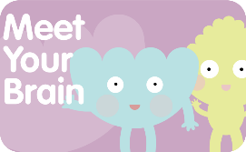
There are 5 modules taught across the year to help children to build resilience, self esteem and confidence.
Meet your brain

Understanding how your brain works and how to ensure we look after it so that we can manage our emotions. Keeping safe and maintaining a healthy lifestyle is included here too.
Celebrate
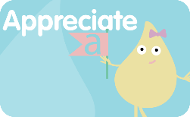
Understanding we are all unique and celebrating our character strengths. This is a fantastic module for building self esteem.
Appreciate
Understanding why gratitude matters and how you can develop gratitude as a habit. Gratitude is key to wellbeing and resilience and we’re all about making it a habit!
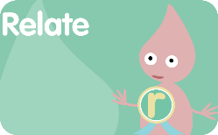
Relate
Understanding why positive relationships matter and how to build them. We’re focussed on the building blocks of good relationships and friendships. We will learn about changes to our bodies as we grow up, keeping ourselves safe, our bodies safe and what is appropriate and inappropriate. We will work alongside the school nurse and guidance from the NSPCC to deliver parts of the curriculum.
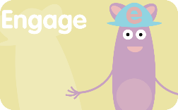
Engage
Understanding how to set meaningful goals that matter and how to keep resilient in times of challenge. Children will also learn about money and finance.

You will be able to find more information about PSHE and RSHE on the school website. If you have any concerns or questions please speak to your child’s teacher.

