Pewithall primary school

Curriculum information 2023-2024

Reception
EYFS Policy & Philosophy at Pewithall.
We deliver an EYFS curriculum through immersion in high quality teaching alongside an enriched environment. Our philosophy is to nurture every child’s curiosity and enthusiasm for learning, developing both skills and confidence as they take their first steps on their own unique journey of lifelong learning.
EYFS Framework 2020
At Pewithall we follow the EYFS framework (2020). Within this framework there are four guiding principles which shape our practice. These are:
1. Every child is a unique child, who is constantly learning and can be resilient, capable, confident, and self-assured.
2. Children learn to be strong and independent through positive relationships.
3. Children learn and develop well in enabling environments with teaching and support from adults, who respond to their individual interests and needs and help them to build their learning over time. Children benefit from a strong partnership between practitioners and parents and/or carers.
4. Children develop and learn at different rates. The framework covers the education and care of all children in early years provision, including children with special educational needs and disabilities (SEND).
EYFS learning and development requirements.
Our curriculum encompasses seven areas of learning and development. All areas of learning and development are important and interconnected. Three areas are particularly important for building a foundation for igniting children’s curiosity and enthusiasm for learning, forming relationships, and thriving. These are called the prime areas:
• communication and language
• physical development
• personal, social, and emotional development.
Four areas help children to strengthen and apply the prime areas. These are called the specific areas:
• literacy
• mathematics
• understanding the world
• expressive arts and design
Throughout their time in the Reception Year our children partake in an ambitious curriculum which is designed in a sequential way to ensure progress towards the end of reception goals. These goals are defined as Early Learning Goals (ELGs) As previously outlined our curriculum incorporates learning through play, learning by adults modelling, by observing each other and through guided learning and direct teaching. It is also important to highlight that our plans are flexible to allow us to respond quickly to children’s new interests and/or needs. Weaving throughout the EYFS curriculum at Pewithall are three Characteristics of Effective Learning.
• playing and exploring - children investigate and experience things, and ‘have a go’
• active learning - children concentrate and keep on trying if they encounter difficulties and enjoy achievements
• creating and thinking critically - children have and develop their own ideas, make links between ideas, and develop strategies for doing things
These elements underpin how we reflect on each child’s development and adjust our practice accordingly. Supporting children in their individual learning behaviour and observing the context of children’s play is essential.
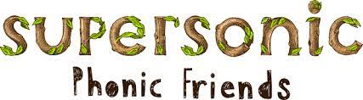
Communication and language
C&L is developed throughout the year through high quality interactions, daily group discussions, sharing circles, PSHE times, stories, singing, speech and language interventions, and if needed Talk Boost interventions.

Personal, Social and Emotional Development
Children’s personal, social and emotional development (PSED) is crucial for children to lead healthy and happy lives, and is fundamental to their cognitive development. Underpinning their personal development are the important attachments that shape their social world. Strong, warm and supportive relationships with adults enable children to learn how to understand their own feelings and those of others. Children should be supported to manage emotions, develop a positive sense of self, set themselves simple goals, have confidence in their own abilities, to persist and wait for what they want and direct attention as necessary. Through adult modelling and guidance, they will learn how to look after their bodies, including healthy eating, and manage personal needs independently. Through supported interaction with other children, they learn how to make good friendships, co-operate and resolve conflicts peaceably. These attributes will provide a secure platform from which children can achieve at school and in later life.
At Pewithall we use My Happy Mind to support our PSED learning. Learners will have the opportunity to read stories and meet characters to support their learning.
Physical development
In Reception our children take part in Multiflex PE lessons, drama lessons with Andrew Curphyy and have lots of opportunities to develop their gross motor skills in our provision and during extra sessions such as GoNoodle, Cosmic Kids Yoga, Daily Mile, further PE lessons and active lessons. We create numorus opportunities for pupils to develop their fine motor skills in the provision and also enjoy noodle drumming and dough disco.

Literacy
Phonics
We use Supersonic Phonics Friends programme to provide daily engaging and active phonics lessons. In phonics, we teach children that the letters of the alphabet represent sounds and that these are put together to make words. The children learn to recognise the different graphemes that they will see when they are reading or writing.
Our phonics teaching starts in Reception and follows a very specific sequence that allows our children to build on their previous phonic knowledge and master specific phonic strategies as they move through school. As a result, all our children are able to tackle any unfamiliar words that they might discover. At Pewithall we also model these strategies in shared reading and writing both inside and outside of the phonics lesson and across the curriculum.
We have a strong focus on the development of language and language skills for our children because we know that speaking and listening are crucial skills for reading and writing in all subjects.
How we Teach Phonics
At Pewithall we:
- Teach children that phonics helps us to read and write.
- Follow a specific lesson structure and teaching sequence (revisit & review, teach, practise, apply) which promotes independence, resilience and success in all our learners.
- Ensure that all phonics teaching is delivered with pace and passion.
- Include an active element to all lessons that ensures participation for all learners.
- Ensure that children take home a book that matches their phonic ability
- Invite all parents to attend phonics and reading workshops to support their children with the development of their child’s phonics skills.
- Many words are phonically regular, however, there are some exceptions, which the children know as tricky words.
Phonics and Reading Books
When the children are starting to learn the phonic code it is important that the books they read are closely matched to the letter sounds they are learning. The books should give the children confidence and help develop fluency, we want our children to feel confident and a sense of achievement.
Writing
Mark making
Throughout each day, children have opportunities for spontaneous mark making, drawing and writing in both the indoor and outdoor environment. Resources are carefully chosen, well organised and attractively presented, so that the children can decide independently how they want to represent their ideas and which medium would best suit their purpose.
At Pewithall we use Greg Bottril’s Message centre concept to engage pupils for a love of writing for purpose and fun.
Pathway’s to Write
At Pewithall Primary School we plan learning in a thematic approach using our English curriculum texts as a driver. We follow The Literacy Company’s ‘Pathways to Write’ scheme which provides high quality texts and further embeds our mastery approach.
Children are given regular opportunities for telling, retelling and refining texts as a preparation for writing. We encourage the process of planning, saying, writing, checking and editing writing.
Planned teaching sequences include shared, guided and independent writing. We prepare children for the transition from shared to independent writing by use of teacher demonstrations-‘modelling’ writing, teacher scribing and supported composition.
Handwriting
At Pewithall Primary School we support our pupils handwriting skills using Letterjoin handwriting programme fonts. In EYFS and year one pupils are taught Letter Join Print Plus font, with lead out lines. We send home the log in details so you can support your child at home with the fun online activities.

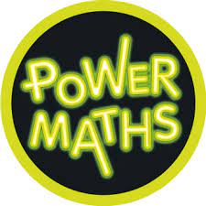
Maths
There’s more to maths than counting!
Children learn about maths through play and their daily experiences. The more meaningful to them and hands on it is, the better. Our setting is full of mathematical opportunities for children to explore, sort, compare, count, calculate and describe. Providing a safe environment to be creative, critical thinkers, problem solvers and to have a go. Mathematics is identified as one of the specific areas of learning, alongside expressive arts and design, literacy, and understanding the world. Our objective is to ensure that all children develop firm mathematical foundations in a way that is engaging, and appropriate for their age. This means actively learning using resources and activities provided in the environment. In addition, maths is explicitly taught daily as short whole class sessions and followed up with small group work using our mastery maths scheme, Power Maths.
Concrete – Pictorial – Abstract
Mastery of mathematical concepts in the EYFS takes the following approach:
Concrete – children use concrete objects and manipulatives to help them understand what they are doing.
Pictorial – children build on this concrete approach by using pictorial representations. These representations can then be used to reason and solve problems.
Abstract – with the foundations firmly laid, children move to an abstract approach using numbers and key concepts with confidence.
Maths is everywhere!
Here are a few examples of how our environment promotes mathematical development:
• Sand & Water can develop mathematical concepts and language, e.g. heavy, light, empty, full, big, little.
• Malleable – dough can develop mathematical language – short, long, fat, thin. Children can make shapes of different dimensions – flat shapes, 3-d shapes.
• Imaginative play - set the table for dinner can develop counting skills. Sorting clothes into different colours, or different types of clothes, e.g. t-shirts and socks will develop knowledge of shapes and colours.
• Physical play can develop fine motor skills e.g. Sorting out a jigsaw, threading beads. Block play or playing with toy cars can help to develop sequencing according to size, colour. Playing with different sized blocks can help to develop an understanding of weight and dimensions. Tidying toys allows children to sort into different sizes and colours. It can also develop mathematical language – first, second, third, how many are blue, which is largest / smallest.
• Outdoors – Children may plant seeds this can develop understanding of time and the life cycle of plants. As the plants grow children use measures and develop mathematical language of size.
• Books & Rhymes - Enjoying stories and rhymes with a mathematical element, e.g. “One-two buckle my shoe” can develop number concepts, knowing direction that the print reads from left to right.
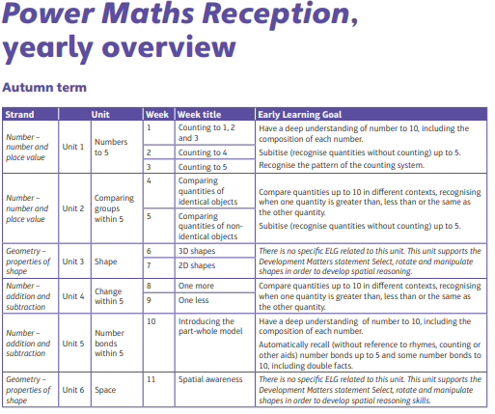

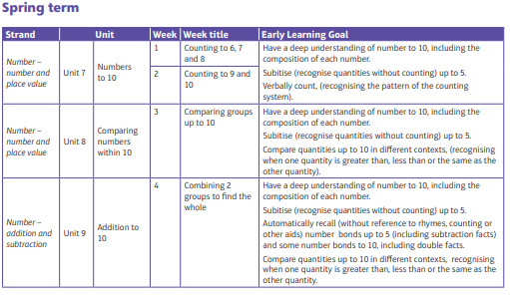

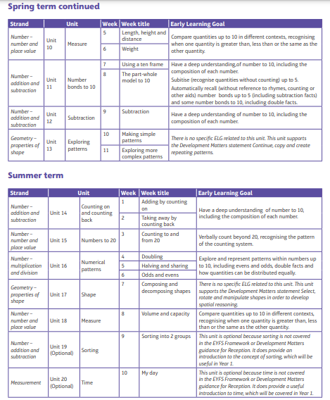

Understanding the World
Understanding the world involves guiding children to make sense of their physical world and their community. The frequency and range of children’s personal experiences increases their knowledge and sense of the world around them – from visiting parks, libraries, and museums to meeting important members of society such as police officers, nurses and firefighters. In addition, listening to a broad selection of stories, non-fiction, rhymes, and poems will foster their understanding of our culturally, socially, technologically and ecologically diverse world. As well as building important knowledge, this extends their familiarity with words that support understanding across domains. Enriching and widening children’s vocabulary will support later reading comprehension.
We like to go from the children’s interests throughout the year such as exploring snow, learning about cultural and significant events and sharing new topics. We use Developing Experts to support our scientific investigations.
Expressive Arts & Design
The development of children’s artistic and cultural awareness supports their imagination and creativity. It is important that children have regular opportunities to engage with the arts, enabling them to explore and play with a wide range of media and materials. The quality and variety of what children see, hear and participate in is crucial for developing their understanding, self-expression, vocabulary and ability to communicate through the arts. The frequency, repetition and depth of their experiences are fundamental to their progress in interpreting and appreciating what they hear, respond to and observe.
We use Charanga to support our music curriculum.
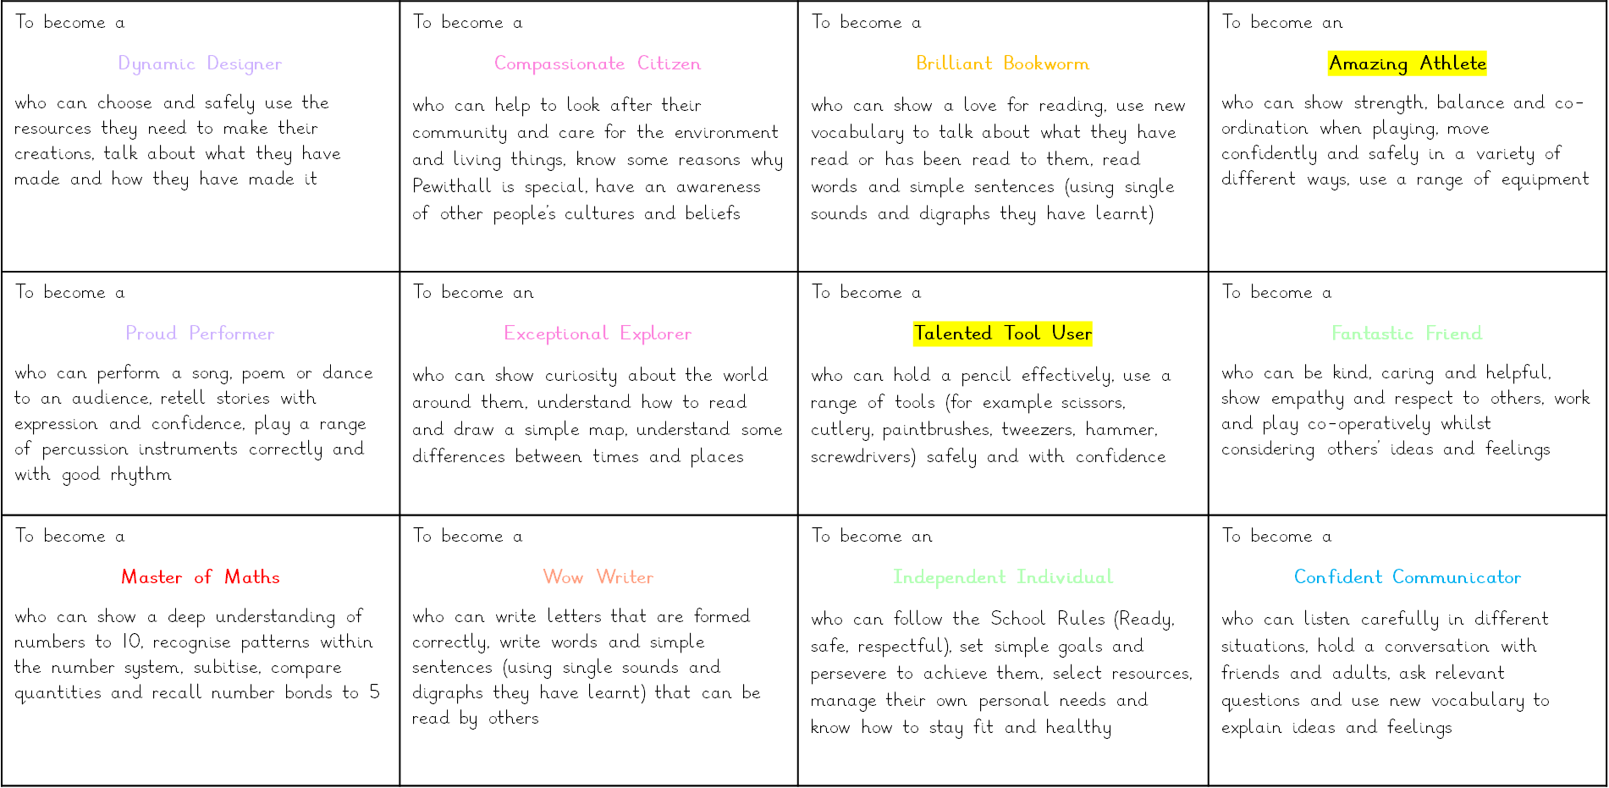
We use our Pewithall Reception Curricular Goals to help our children understand their learning. We discuss these goals with the children.

