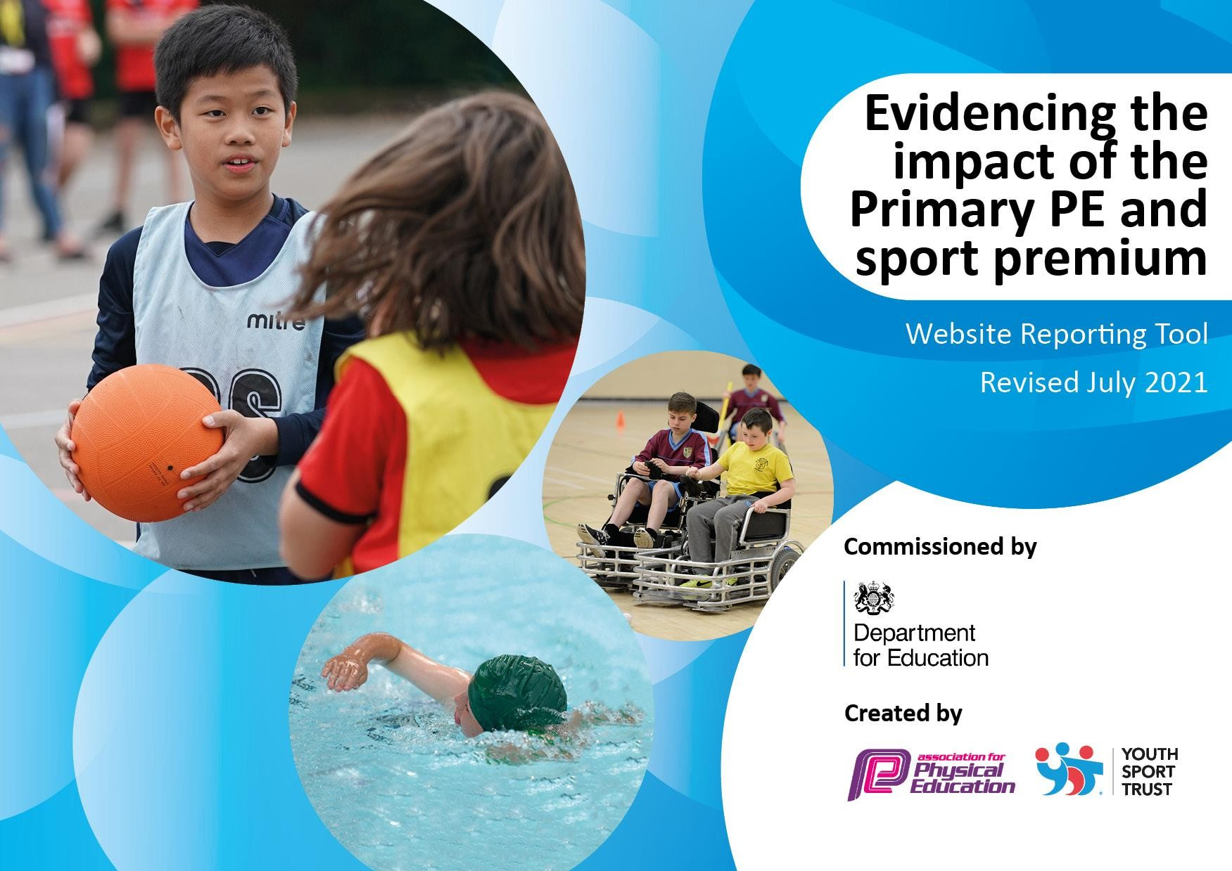

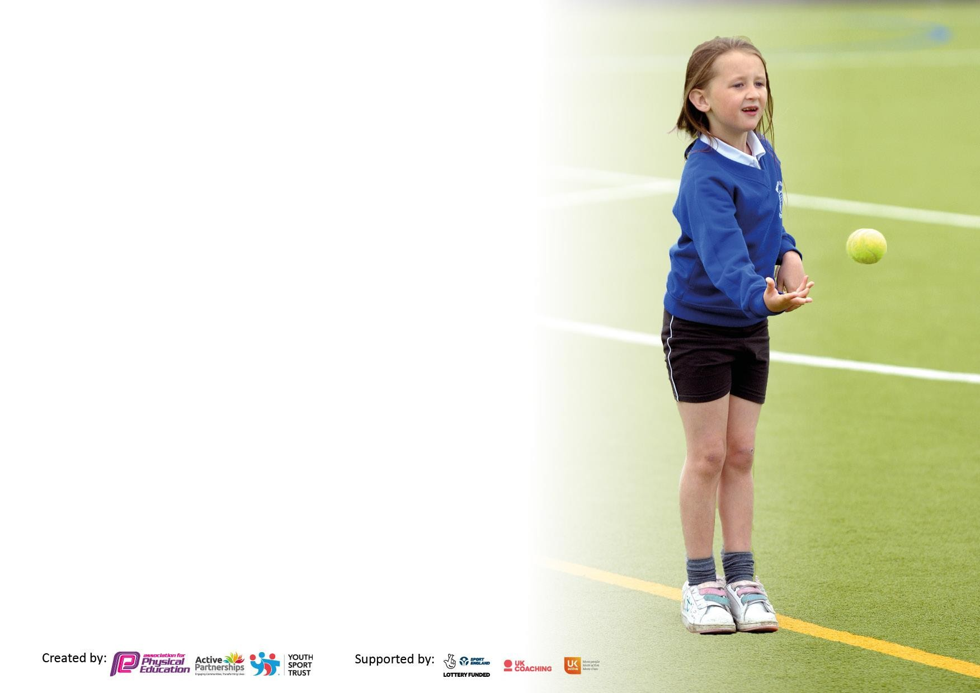
It is important that your grant is used effectively and based on school need. The Education Inspection Framework makes clear there will be a focus on ‘whether leaders and those responsible for governors all understand their respective roles and perform these in a way that enhances the effectiveness of the school’.

Under the Quality of Education Ofsted inspectors consider:
Intent - Curriculum design, coverage and appropriateness
Implementation - Curriculum delivery, Teaching (pedagogy) and Assessment
Impact - Attainment and progress

To assist schools with common transferable language this template has been developed to utilise the same three headings which should make your plans easily transferable between working documents.

Schools must use the funding to make additional and sustainable improvementsto the quality of Physical Education, School Sport and Physical Activity (PESSPA) they offer. This means that you should use the Primary PE and sport premium to:

- Develop or add to the PESSPA activities that your school already offer
- Build capacity and capability within the school to ensure that improvements made now will benefit pupils joining the school in future years
- The Primary PE and sport premium should not be used to fund capital spend projects; the school’s budget should fund these.

Pleasevisitgov.ukfortherevisedDfEguidanceincludingthe5keyindicatorsacrosswhichschoolsshoulddemonstrate animprovement.Thisdocumentwillhelpyoutoreviewyourprovisionandtoreportyourspend.DfEencouragesschools to use this template as an effective way of meetingthereporting requirements of the Primary PE and sport premium.

We recommend you start by reflecting on the impact of current provision and reviewing the previous spend.

Schools are required to publish details of how they spend this funding, including any under-spend from 2019/2020, as well as on the impact it has on pupils’ PE and sport participation and attainment. All funding must be spent by 31st July 2022.

We recommend regularly updating the table and publishing it on your website throughout the year. This evidences your ongoing self-evaluation of how you are using the funding to secure maximum, sustainable impact. Final copy must be posted on your website by the end of the academic year and no later than the 31st July 2021. To see an example of how to complete the table please click HERE.
Created by: Supported by:

Details with regard to funding
Please complete the table below.

Total amount carried over from 2021/22 | £0
Total amount allocated for 2022/23 | £17,850
How much (if any) do you intend to carry over from this total fund into 2023/24? | £3948.17
Total amount allocated for 2022/23 | £17850-
Total amount of funding for 2022/23. To be spent and reported on by 31st July 2023. | £13901.83 CF – 23/24 (£3948.17)
Swimming Data
Please report on your Swimming Data below.

Meeting national curriculum requirements for swimming and water safety.

N.B. Complete this section to your best ability. For example you might have practised safe self-rescue techniques ondry land which you can then transfer to the pool when school swimming restarts.
Due to exceptional circumstances priority should be given to ensuring that pupils can perform safe self rescue evenif they do not fully meet the first two requirements of the NC programme of study
What percentage of your current Year 6 cohort swim competently, confidently and proficiently over a distance of at least 25 metres?  N.B. Even though your pupils may swim in another year please report on their attainment on leaving primary schoolat the end of the summer term 2021.  Please see note above | 82%
What percentage of your current Year 6 cohort use a range of strokes effectively [for example, front crawl, backstroke and breaststroke]?  Please see note above | 82%
What percentage of your current Year 6 cohort perform safe self-rescue in different water-based situations? | 100%
Schools can choose to use the Primary PE and sport premium to provide additional provision for swimming but thismust be for activity over and above the national curriculum requirements. Have you used it in this way? | No

Action Plan and Budget Tracking
Capture your intended annual spend against the 5 key indicators. Clarify the success criteria and
evidence of impact that you intend to measure to evaluate for pupils today and for the future.

Academic Year: 2020/21 | Total fund allocated: | Date Updated:
Key indicator 1: The engagement of all pupils in regular physical activity – Chief Medical Officers guidelines recommend that primary school pupils undertake at least 30 minutes of physical activity a day in school |  |  |  | Percentage of total allocation:
 |  |  |  | 28%
Intent | Implementation |  | Impact | £5040
Your school focus should be clear what you want the pupils to know and be able to do and about what they need to learn and to consolidate through practice: | Make sure your actions to achieve are linked to your intentions: | Funding allocated  : | Evidence of impact: what do pupils now know and what can they now do? What has changed?: | Sustainability and suggested next steps:
Install covered areas for bikes and scooters to promote active travel to school. | Pupils will meet and exceed the expectation to be active for at least 30 minutes a day. | - | Promote regular ‘bike to school’ days for year groups to encourage active travel to school.Y5/6 will access Bikeability programme. | Bike/Scooter racks to be purchased and placed outside different classrooms for children to leave securely.
Provide classes with a range of playtime equipment (e.g. balls and skipping ropes).  Select playground equipment monitors who will ensure all  equipment is collected and returned every lunch time. | New lunchtime equipment purchased to make break times active. | £4560 | Pupils will be more active during break and will take care of  the equipment that they are given. | Increase the variety of equipment on offer (pupil voice).
Provide 30 minutes lunch sports club for the class that wins ‘class of the week’ on a Thursday.  Dancing lunchtime Wednesday club. | Specliasit PE coach and Dance Teacher to lead lunchtime clubs to meet and exceed the expectation to be active for at least 30 minutes a day. | £480 | Children develop better play practices and how they can increase resilience, work collaboratively and show sportsmanship. | Incentive for each class to follow the school rules and become ‘class of the week’.

Key indicator 2: The profile of PESSPA being raised across the school as a tool for whole school improvement | Percentage of total allocation:
 | 6.16%

Intent | Implementation |  | Impact | £1100
Your school focus should be clear what you want the pupils to know and be able to do and about what they need to learn and to consolidate through practice: | Make sure your actions to achieve are linked to your intentions: | Funding allocated: | Evidence of impact: what do pupils now know and what can they now do? What has changed?: | Sustainability and suggested next steps:
Linking ‘Happy Minds’ scheme to promote positive wellbeing for school to have wellbeing sport focused days. | Specialist coach Mr Rae to lead these sessions. | £320 | Children to show positive attitude towards sports and use exercise to increase wellbeing. | Children have enjoyed being part of a sports club before the school day has started on a Monday and Wednesday morning.
Provide all Year 4, 5 and 6 pupils with a course of intensive swimming lessons. Year 6 will also be given booster swimming sessions during the Summer term. | Pupils in Year 6 will meet end of KS2 requirements for swimming 25m, using a range of strokes and performing water safety. | £390 | Aim to send all KS2 pupils  to swimming sessions each year. Main focus on Year 5 and 6 for booster sessions. | Children have enjoyed swimming lessons and CPD opportunity for staff. All children have completed water safety lessons.
Increase the range of sporting opportunities in a competitive setting for Sports Day. | Improve and invest in sports day equipment. | £710 | Knew nerf howlers, egg and spoons and bouncers were bought. | Equipment to be used again next year for sports day.

Key indicator 3: Increased confidence, knowledge and skills of all staff in teaching PE and sport |  |  |  | Percentage of total allocation:
 |  |  |  | 13.9%
Intent | Implementation |  | Impact | £2445
Your school focus should be clear | Make sure your actions to | Funding | Evidence of impact: what do | Sustainability and suggested
what you want the pupils to know | achieve are linked to your | allocated: | pupils now know and what | next steps:
and be able to do and about | intentions: |  | can they now do? What has
what they need to learn and to |  |  | changed?:
consolidate through practice:

Purchase Get Set 4 PE Scheme. To increase confidence, knowledge and skills of all staff in teaching PE and sport.  Purchase a PE ‘Ipad’ so teachers can take pictures/videos in PE lessons to upload to Get Set 4 PE webpage. | Teachers to understand and use the scheme to increase confidence teaching and assessing PE.  Assessment of children in shown throughout the different strands of  PE. | Ipad £350 Get Set PE  £1375 | A large data base of pictures/videos of assessment logged on The Get Set 4 PE website to show progression of skills.  Assessment of PE will become a strength in school | Continue to use scheme for next 2 years. Teachers have had the chance to use Get Set 4 PE under Mr Rae’s CPD sessions.
Maintaining the high profile for PEPSA by hiring specialist P.E. practitioners which encourages pupils and teachers to engage in healthy lifestyles. | Specialists will work alongside teachers supporting their professional development. – Jack Rae to support staff with staff confidence teaching PE | £720 | Raised quality of teaching, learning and assessment resulting in high levels of pupil engagement.  Opportunities to develop a wider set of physical literacy skills has been obtained.  Increased levels of pupil self- esteem and confidence.  Staff are more confident and knowledgeable in the delivery of PE curriculum – evidence from staff voice  Children experience a broad range of sporting opportunity including minority sports. | Staff to continue to use Get Set 4 PE planning and assessment tool.
Staff will use swimming lessons as a CPD opportunity. Staff will carry out extra sessions in the classrooms to recap water safety. | KS2 staff will have the knowledge of expectations for end of KS2.  They will feel confident when discussing water safety back in the class room too. |  | More children to leave Pewithall Primary School being able to swim 25m and successfully complete water safety. | To continue next year.

Key indicator 4: Broader experience of a range of sports and activities offered to all pupils |  |  |  | Percentage of total allocation:
 |  |  |  | 21.21%
Intent | Implementation |  | Impact | £3786.83
Your school focus should be clear | Make sure your actions to | Funding | Evidence of impact: what do | Sustainability and suggested
what you want the pupils to know | achieve are linked to your | allocated: | pupils now know and what | next steps:
and be able to do and about | intentions: |  | can they now do? What has
what they need to learn and to |  |  | changed?:
consolidate through practice:
School to use outdoor grounds better and have a specialist come in to set up an orienteering course/map. | School to have a successful orienteering course which can be linked to maths/geography objectives. | - | Children to use the school grounds and learn orienteering skills. | Not happened this year due to provider not setting up the course- Look into alternative providers for next year.
Gymnastics equipment health and safety checked, with any damaged equipment replaced. | Money charged covers equipment check, health and safety certification and maintenance where required to P.E and play equipment. | £500 | Children to be using safe gymnastic equipment. | Take place yearly. School will have to replace to gymnastic mats for next year.
SEN children and ELSA children to receive additional support. | Mr Rae to run a support session on a Monday/Wednesday morning for children to improve specific skills. | £960 | Children to start the day in a positive way. | Children have grown in confidence and taken part in sports that we don’t cover in normal PE lessons such as archery and curling.

Children to participate in skiing, high ropes, cannoning, inflatable park and orienteering. | School to subside school residential trips for Year 2,3, 5,6 children. | Skiing: £410.83 Conwy: £1500 FH Ranger: £660 Inflate: £700 | Children to complete in sports that they may never have had the opportunity to have. | Review residential and book again for next year.
Children to have a broader opportunity to participate in different sports. | Pay for external providers to come into school and give pupils a range of sporting opportunities e.g. trampoline fitness, rugby, yoga, archery, orienteering. | Galaxy Bounce:  £110  JDK  Trampolines:  £440 | An increased number of pupils will take part in a wider variety of sports and have at least one sport which they enjoy taking part in. | Continue to find new opportunities for the pupils so that they can try a variety of sports.

Key indicator 5: Increased participation in competitive sport |  |  |  | Percentage of total allocation:
 |  |  |  | 8.57%
Intent | Implementation |  | Impact | £1530
Your school focus should be clear | Make sure your actions to | Funding | Evidence of impact: what do | Sustainability and suggested
what you want the pupils to know | achieve are linked to your | allocated: | pupils now know and what | next steps:
and be able to do and about | intentions: |  | can they now do? What has
what they need to learn and to |  |  | changed?:
consolidate through practice:
To maintain the high volume of pupils attending enrichment activity and inter-school competition – e.g. Halton inter-school competitions and School Games. Increased opportunity will  improve pupils’ motivation and social interaction thus having an impact on children’s academic achievement. | Increasing opportunity via attendance at inter-school competition.  Bus hire for attending.  Supply cover to free travelling staff. Membership fees, affiliation and entry fees to a range of competitions and events. | £450 | More children to represent Pewithall outside of school in competitions. | Continue to work with Halton School Games next year.
Multi Flex (Mr Rae) to organise and run intra house sporting competitions in a range of different sports. | Imbed the school rules of ‘Be  ready, safe and respectful’ whilst playing sport. Children to compete against different year groups. | £1080 | Children to be proud in representing their year group in a safe environment where the school rules can be imbedded. | Children have enjoyed the extra in-house competitions- use pupil voice and look into what major sporting competitions are happening next year.
Children to be provided with rugby coaching sessions from specialist coach from Widnes Vikings. | Increase links with a local professional sports club. Children from year 3,4,6 have played at the stadium in rugby fixtures. | £0 | Children have received free tickets to go and watch the Widnes Vikings vs Bradford Bulls and received specialist coaching. | Teachers have been shadowing the rugby coach in these lessons and developed more confidence in coaching rugby.

Signed off by
Head Teacher: | X  David Baugh Head Teacher
Date: | 09072023
Subject Leader: | X  Peter Stirk  Sports and PE Leader
Date:
Governor: | X  Neil Burgess  Sports Premium Governor and Vice Chair
Date:

