Vocabulary | Definition
Scandinavia | The countries of Norway, Sweden and Denmark. This is the area the Vikings came from.
rune | A letter from the alphabet used by Vikings
raid | A surprise attack
massacre | The murder of a large number of people.
Wergild | The money a person or piece of property was thought to be worth. If a person was killed, their family would be paid wergild by the killer
Danegeld | Money paid to the Vikings to stop them from raiding
Anglo-saxons | The main group of people living in Britain when the Vikings invaded.
Danelaw | The area of land in Britain that the Danish Vikings ruled.
Treaty | An agreement made between two or more people, groups or countries
Pagan religion | A group of traditional religions. Many of these worship several gods or goddesses and nature is seen as very important.
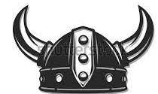
The Vikings
Figures | Events
Alfred the great | First Viking raids
Athelstan and Constantine | Danelaw
King Canute and Emma | Viking Jorvik (York)
Edward the Confessor | St Brice’s Day Massacre
Enquiry questions
Who were the Vikings and what did they do?
Why did they raid other countries?
Were the Vikings always fighting?
What did Vikings believe in? Did they have laws?
How did Vikings communicate?
Who was ‘Edward the Confessor’?
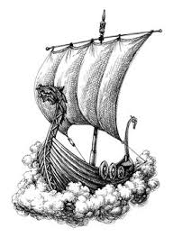
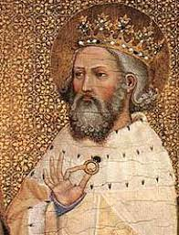
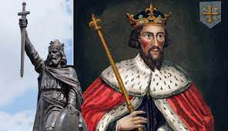
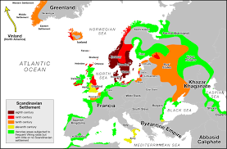
Timeline:
- 793 AD: Viking raid on the monastery of Lindisfarne
- 865 AD: Great Viking Army invades England
- 878 AD: King Alfred the Great defeats the Viking army
- 1013 AD: Danish king Sweyn Forkbeard conquers England
- 1016 AD: King Edmund Ironside and Cnut the Great agree to divide England
- 1066 AD: King Harold defeated by William the Conqueror, bringing an end to Viking rule in England.

