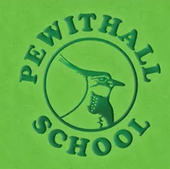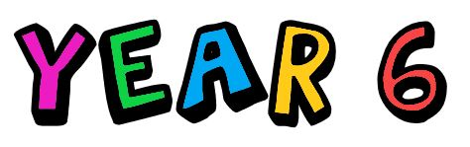**Pewithall Primary School**

**Curriculum booklet 2023-2024**

This year, your child will be in Year 6. This year is an exciting and special year. Not only will they be coming to the end of their learning in KS2, but they will also begin to get ready for their transition to secondary school. Your child will also complete their SATs. In order to be successful in Year 6, your child needs to be ready to: smile, laugh, learn, ask for help, be independent, be their best and make every Pewit moment count- this year goes very quick!

**This year your child will study:**

***Writing/SPaG***



, Year 6 will be taught English using a scheme called Pathways to write.

Pathways is a brand-new methodology designed to equip pupils with key skills to move them through the writing process towards their final outcome. It is built around units of work that follow a mastery approach to the teaching of writing.

To support this approach, clear detailed lesson plans and resources are linked to a high-quality text. Pathways to Write ensures engaging and purposeful English lessons. The units can be used thematically to encourage a whole school approach to writing with the opportunity for topics to link across all year groups.

Each unit covers a range of areas in the national curriculum:

Mastery of vocabulary, grammar and punctuation skills

Writing a range of genres across a year

Vocabulary development

Using a wider range of reading comprehension strategies as a whole class

Spoken language activities including drama and presentations

Opportunities for practising previously taught genres

An extended, independent piece of writing.

Your child will read the following books below. The text in blue will be our class novel and it would be beneficial if your child had their own copy of this text.

|  |  |  |  |  |  |
| --- | --- | --- | --- | --- | --- |
| **Autumn 1** | **Autumn 2** | **Spring 1** | **Spring 2** | **Summer 1** | **Summer 2** |
| Star of Hope, Star of Fear by Jo Hestlandt  **An Eagle in the snow by Michael Morpurgo** | Can we save the tiger? By Martin Jenkins  **Jungle Book by Rudyard Kipling** | Selfish Giant by Oscar Wilde  **Gulliver’s Travels retold by Martin Jenkins** | The Day War Came by Nicola Davies | Plastic Planet By Georgia Amson-Bradshaw | William Shakespeare By Marguerite Tassi |

***Reading***

In Year 6, we do guided reading every day. The children will already be familiar completing VIPERS in Year 5. The children will be given a new age-related text in class, each week.

Firstly, they will generate questions and predictions about their text and the following session the children will read this text with their reading group and an adult to support and discuss the themes, language features and plot of the text. Following this session, the children will complete their VIPER sheet where their comprehension skills will be needed and the understanding of the text.

The children will also complete a short SATs style question. This will be based on another text and will make the children familiar with the reading booklet layout and the amount of text, which they will need to be able to read, understand and apply to the question given.

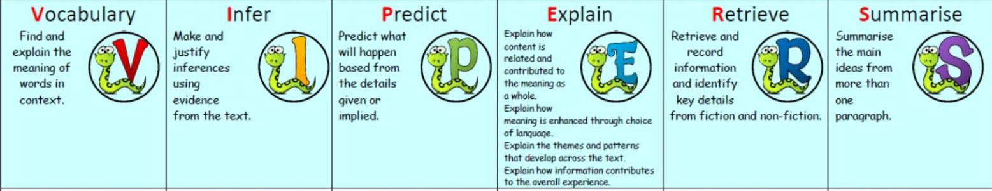

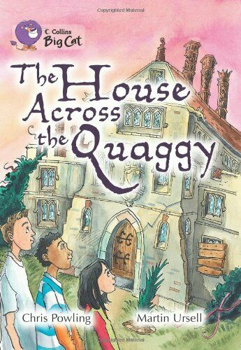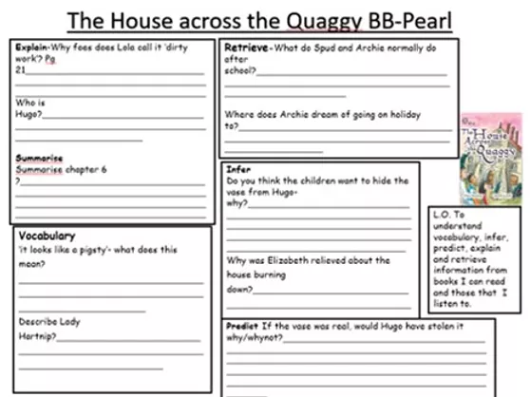

**What can you do to help?**

Please ensure that you read with your child regularly. Sign their diary and encourage them to read books of their interests. Even reading football match reports in the newspaper can support their reading and confidence as well as their love for reading. Support them when reading different genres of texts- magazines, newspapers, novels, diaries etc.

The children will read longer texts this year. It is vital that they read regularly so they are fluent and have the stamina to read for longer periods of time.

Spelling tests will be on **Wednesdays**. The children will be given their new spellings on this day. If your child loses their spellings, they are ***always*** available in the pot in our reading area. Please encourage them to take responsibility for organising themselves and practising at home.

***Maths***

Year 6 use Power Maths as our Maths scheme. The children will be familiar with the scheme and objectives from Year 5. Many of the objectives in Year 6 are first visited in Year 5, so the children will be familiar with certain topic areas and in some cases will just be consolidating their knowledge.

Below is the year overview of the topics, that your child will be taught.

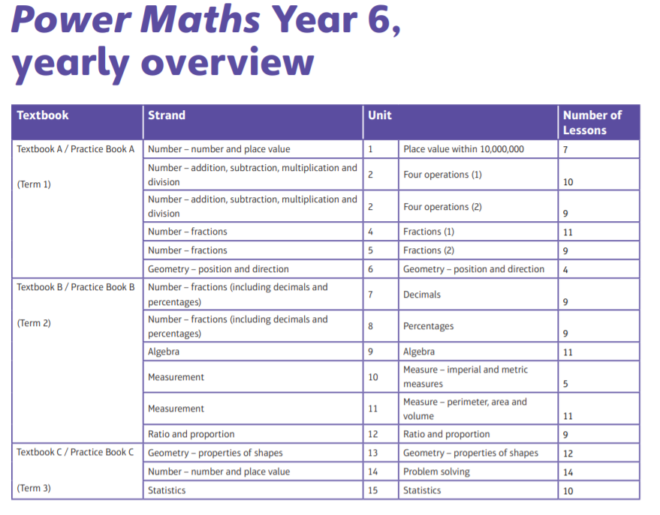

This year your child will be learning and consolidating the following knowledge and skills:

* They will extend their understanding of the number system and place value to include larger integers and this will develop the connections that they make between multiplication and division with fractions, decimals, percentages and ratio.
* The children will develop their ability to solve a wider range of problems, including increasingly complex properties of numbers and arithmetic, and problems demanding efficient written and mental methods of calculation.
* With this foundation in arithmetic, the children will be introduced to the language of algebra as a means for solving a variety of problems.
* In geometry and measures, the children will consolidate and extend the knowledge that they have developed in number.
* The children will learn to classify shapes with increasingly complex geometric properties, and they will learn the vocabulary they need to describe them.
* Throughout Year 6, the children will develop fluency in written methods for all four operations, including long multiplication and division, and in working with fractions, decimals, and percentages.

**What can you do to help?**

Please ensure that your child knows all their times tables and related division facts. Please also help your child to practise creating derived facts from times tables: 3 x 6 = 18, so 30 x 6 is 180, or 42 ÷ 0.7 = 60. Another extremely useful thing for them to know is how to convert between decimals, percentages, and fractions. For example, that ½ is the same as 50% which is the same as 0.5 etc.

Encourage the children to use the apps- Sumdog and TT Rockstars.

***Science***

Science is taught using a scheme called Developing Experts. In lessons children will be exposed to scientific vocabulary, watch videos of real life scenarios where the science concept they are learning about is being used. They will engage in experiments and working scientifically.

******In Science, Year 6 will study the following topics:

* Animals Including Humans
* Light
* Evolution and Inheritance
* Electricity
* Living Things and their Habitats

**What can you do to help?**

Please use our class page on the school website to access the knowledge organisers.

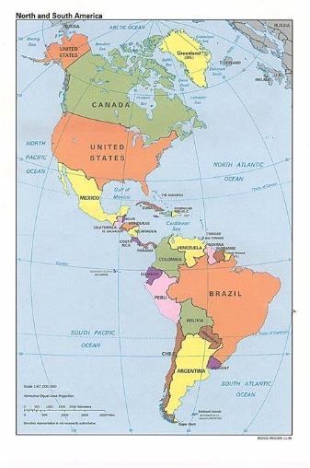

***Learning Projects***

Learning project is the umbrella term for geography, history, art and design, design and technology, and music. The topics this year will also link to the texts which your child will use in English. These subjects will be taught through the following themes:

. The Vikings

. Civil Rights

. North and South America

**What can you do to help?**

Please use our class page on the school website to access the knowledge organisers.

In **Art and Design**, the children will learn and practise the following objectives:

* They will create sketch books to record their observations and use them to review and revisit ideas
* They will improve their mastery of art and design techniques, including drawing, painting, and sculpture with a range of materials [for example, pencil, charcoal, paint, clay]
* They will learn about great artists, architects, and designers in history.

In **Design and Technology**, through a variety of creative and practical activities, the children will be taught the knowledge, understanding and skills needed to engage in an iterative process of designing and making. They will work in a range of relevant contexts [for example, the home, school, leisure, culture, enterprise, industry and the wider environment] and within the context of the overarching curriculum themes.

In **Geography**, the children will extend their knowledge and understanding beyond the local area to include the United Kingdom and Europe, North and South America. This will include the location and characteristics of a range of the world’s most significant human and physical features. They will develop their use of geographical knowledge, understanding and skills to enhance their locational and place knowledge.

In **History**, the children will continue to develop a chronologically secure knowledge and understanding of British, local and world history, establishing clear narratives within and across the periods they study. They will note connections, contrasts and trends over time and develop the appropriate use of historical terms. They will regularly address and sometimes devise historically valid questions about change, cause, similarity and difference, and significance. They will construct informed responses that involve thoughtful selection and organisation of relevant historical information. They will understand how our knowledge of the past is constructed from a range of sources.

In **Music**, the children will be taught to sing and play musically with increasing confidence and control. They will develop an understanding of musical composition, organising and manipulating ideas within musical structures and reproducing sounds from aural memory.

***PE***

Children will be taught to:

* use running, jumping, throwing and catching in isolation and in combination
* play competitive games, modified where appropriate [for example, badminton, basketball, cricket, football, hockey, netball, rounders and tennis], and apply basic principles suitable for attacking and defending
* develop flexibility, strength, technique, control and balance [for example, through athletics and gymnastics]
* perform dances using a range of movement patterns
* take part in outdoor and adventurous activity challenges both individually and within a team
* compare their performances with previous ones and demonstrate improvement to achieve their personal best.

P.E teaching will be taught by Multiflex on **Monday.**

***Religious Education***

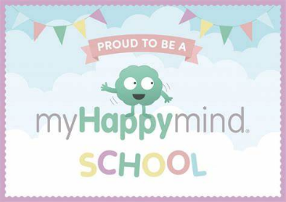In Religious Education, the children will use developing religious vocabulary to describe and show understanding of religious traditions, including sources, practices, beliefs, ideas, feelings and experiences. They will also compare different viewpoints within a faith group. They will explain what inspires and influences them, expressing their own views whilst respecting other people. They will ask important questions about religion and beliefs. They will analyse religious information and begin to develop their own opinions.

The religions covered will be: Christianity, Sikhism and Buddhism.

***RSE and PSHE***

We have adopted a new Scheme this year to PSHE called My Happy Mind. This scheme aims to allow children to understand their mind, emotions and feelings. The lessons will give the children opportunities to express themselves and learn ways to positively outlet any emotions.

Alongside the My Happy Mind Scheme Year Six will also look at other PSHE topics:

. All about me

. My choices

. My body

. My Boundaries

. My relationships

. My thoughts and feelings

Spiritual

Explore beliefs and experience; respect faiths, feelings and values; enjoy learning about ourselves, others and the surrounding world.

Moral

Recognise right and wrong; respect the law; understand consequences; investigate moral and ethical issues; offer reasoned views.

Social

Use a range of social skills; participate in the local community; appreciate diverse viewpoints; participate, volunteer and cooperate; resolve conflict; engage with the 'British values' of democracy, the rule of law, liberty, respect and tolerance.

Cultural

Appreciate cultural influences; appreciate the role of Britain's parliamentary system; participate in culture opportunities; understand, accept, respect and celebrate diversity.We will aim these four areas throughout the curriculum.

What can you do to help?

Help your child to understand and develop positive relationships with those around us through discussions.

Encourage your child to talk about the knowledge organisers which they are looking at in school.

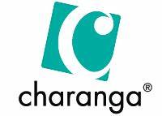***Music***

We use Charanga to teach our children music.

Children will be taught to:

. sing and play musically with increasing confidence and control.

. They should develop an understanding of musical composition, organising and

manipulating ideas within musical structures and reproducing sounds from aural memory.

Pupils should be taught to:

. play and perform in solo and ensemble contexts, using their voices and playing musical

instruments with increasing accuracy, fluency, control and expression

. improvise and compose music for a range of purposes using the inter-related

dimensions of music

. listen with attention to detail and recall sounds with increasing aural memory

. use and understand staff and other musical notations

. appreciate and understand a wide range of high-quality live and recorded music drawn

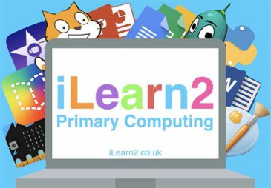from different traditions and from great composers and musicians

. develop an understanding of the history of music

***Computing***

In Year 6, the children will learn to:

* design, write and debug programs that accomplish specific goals, including controlling or simulating physical systems; solve problems by decomposing them into smaller parts
* use sequence, selection, and repetition in programs; work with variables and various forms of input and output
* use logical reasoning to explain how some simple algorithms work and to detect and correct errors in algorithms and programs
* understand computer networks including the internet; how they can provide multiple services, such as the world wide web; and the opportunities they offer for communication and collaboration
* use search technologies effectively, appreciate how results are selected and ranked, and be discerning in evaluating digital content
* select, use and combine a variety of software (including internet services) on a range of digital devices to design and create a range of programs, systems and content that accomplish given goals, including collecting, analysing, evaluating and presenting data and information
* use technology safely, respectfully and responsibly; recognise acceptable/unacceptable behaviour; identify a range of ways to report concerns about content and contact.

## What can you do to help?

We use the scheme Ilearn2. Please check your weekly homework letter for the activity code to practise your computing skills at home.

***Spanish***

Pupils at Pewithall School learn Spanish and enjoy the benefits of starting to learn a foreign language at such an early age. We teach through songs, videos, games, interactive activities and lessons based on a practical communicative approach.

Our aim is to ensure that children develop a good basic understanding and a love of Spanish. We help them acquire the foundations for further foreign language learning at Key Stage 3 and a smoother transfer to Secondary School.

We endeavour to enable our pupils to express their ideas and thoughts in another language by working on the four basic language skills: speaking, listening, reading and writing. Excellent accent and intonation are reinforced in every lesson since we believe in a “Talk for writing approach”

Our stimulating curriculum and an eclectic approach to teaching enables us to use different techniques and resources to provide our children with a high-quality language education. Sessions are aimed at infusing children a love of Spanish and children like Spanish because they can enjoy playing with the language and become life-long lovers of Spanish whilst maintaining high educational expectations. As we will be using Duolingo for Schools to deliver this curriculum, we hope that the love of languages will be a strong focus of home learning too inspiring our families and home life.

Learning a foreign language provides an opening to other cultures, fosters children´s curiosity and deepens their understanding of the world. All children regardless of their background and ability are encouraged to develop their full potential in Spanish. All pupils feel engaged and enjoy learning Spanish within the context of the culture of the Hispanic world.

https://www.duolingo.com/classroom Click here to get started!

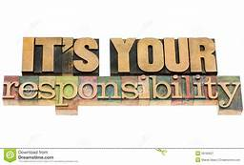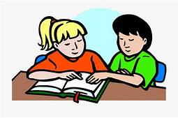

***Homework***

Homework will be sent home on a Thursday. Your child will have until the following Wednesday to complete this and send it back to school (6 evenings to complete). I cannot stress enough that your child’s homework should be their responsibility. I completely support you helping them, if they are struggling or giving them a gentle reminder to complete it, but it is important they are **responsible** and are preparing themselves for secondary school, where organisation is key and getting tasks completed will be a basic expectation.

We offer a homework club once a week at lunch time for children to complete their homework in school rather than home. It is not to be used as a social club but a place where children can get support if they need it. I would strongly advise your child attempting their homework at home first, if they have struggled on a question/concept, they are more than welcome to attend homework club. It is important they try their best first.

Late homework or failing to hand it in will result in your child doing their homework at lunch time and break- again in secondary school, this would be a detention.

The children will also receive weekly spelling lists for a spelling test on Wednesday. Please spend time working with your child on learning their spellings, but please also ensure that they understand what every word means and can use it in context.

Reading diaries will be checked daily, if not every other day. Please sign and date that your child has read their book. It is your child’s responsibility to swap their book once their diary has been signed. Again, these books are available in our reading area in our home reading basket.