Vocabulary | Definition
Civil rights | the rights of citizens to political and social freedom and equality.
Discrimination | he unjust or prejudicial treatment of different categories of people, especially on the grounds of ethnicity, age, sex, or disability
Segregation | the action or state of setting someone or something apart from others
Boycott | withdraw from commercial or social relations with (a country, organization, or person) as a punishment or protest
Equality | the state of being equal, especially in status, rights, or opportunities:
Diversity | the practice or quality of including or involving people from a range of different social and ethnic backgrounds and of different genders
Protest | a statement or action expressing disapproval of or objection to something
campaigns | an organized course of action to achieve a goal
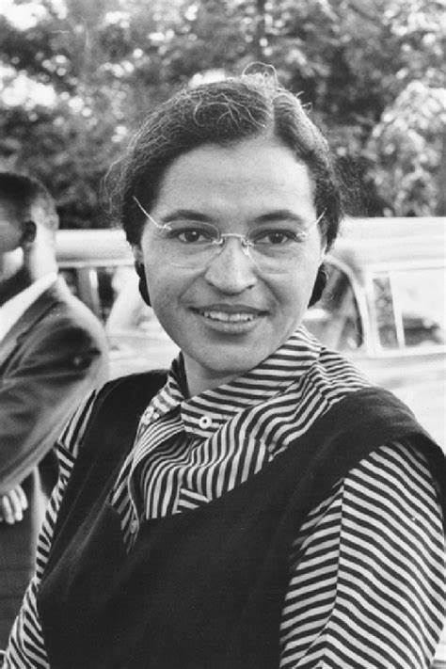
Civil Rights
Figures | Events
Nelson Mandela | The March on Washington
Martin Luther King Jr. | The Bristol Bus Boycott
Rosa Parks | Civil rights movement in the US and UK
Paul Stephenson | Nelson Mandela Day 2023
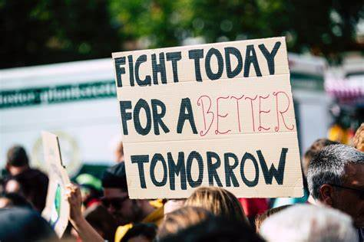
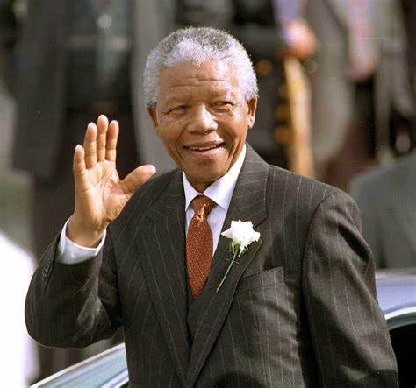
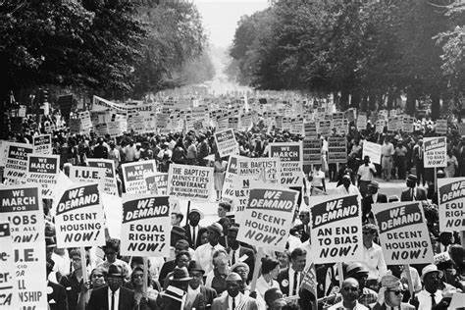
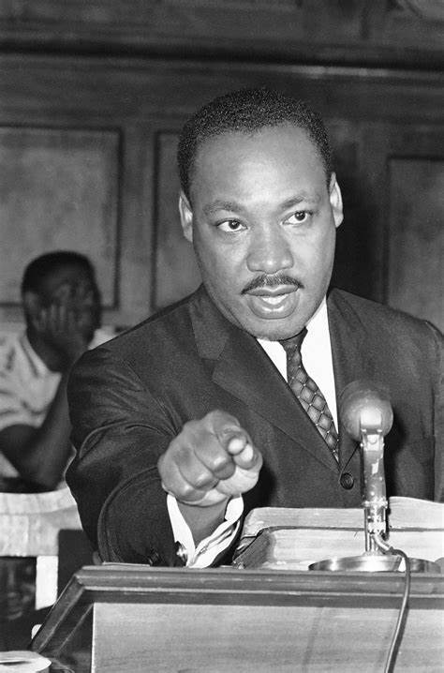
Enquiry questions
What is civil rights?
What did segregation and discrimination look like in the US and UK during the era of Martin Luther King?
Why do people fight for civil rights?
What is the point in a protest?
What did Rosa Parks do and why?
Who is Nelson Mandela?

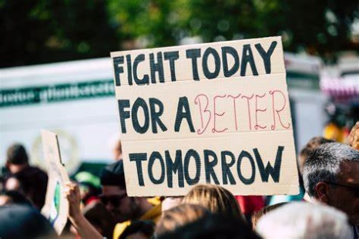
Civil Rights
K  What do I already Know? | W  What would I like to learn? | L  What I have learned…

